Human Behaviour Recognition Based on Multiscale Convolutional Neural Network

INTRODUCTION
In the field of computer vision, the research on human behavior recognition can not only develop the relevant theoretical basis, but also expand its engineering application. For the theoretical basis, the field of behavior recognition integrates the knowledge of many disciplines, such as image processing, computer vision, artificial intelligence, human kinematics and bioscience. Human behavior recognition is an important method to process video content using computer vision technology. It is an important research direction .
According to the different forms of convolution kernel, behavior recognition methods based on deep learning can be divided into two categories: 2D convolution network and 3D convolution network, many researchers have applied deep learning to motion recognition. They have tried to use various methods to realize the behavior recognition technology based on computer vision, and achieved good results. The specific methods and literature will be analyzed in detail in Chapter 1. These behavior recognition methods can be roughly divided into two categories: one is behavior recognition technology based on traditional classification methods; The second is behavior recognition technology based on deep learning. Combining the advantages of these two methods, the mainstream research direction of current behavior recognition technology is to use the method of manual feature extraction combined with deep learning. However, due to the complexity of human behavior itself, and human behavior is easily disturbed by complex background, occlusion, light and other environmental factors, most of the current feature extraction methods are cumbersome and prone to error transmission, Moreover, it is difficult to effectively model the relatively slow or static behavior. In addition, the convolutional neural network with a single scale can not fully describe the human behavior characteristics from multiple angles, which is not conducive to the final behavior recognition.
In the research of domain, a large number of efficient network structures have emerged, such as C3R, eco, TSN etc. Although these network models are different in structure, they all have high modelling ability for video data and can effectively distinguish different human behaviors in natural scenes. Theoretically, the feature description vectors obtained from different network models are sensitive to category information (taking the classification task as an example), and become linearly separable at the output layer of the network. Even if they come from different modeling processes, the feature vectors obtained should be similar. Whether the knowledge acquired by different network structures can be learned and shared is a problem worth discussing. Chen et al. increased the width and depth of the original network, used the decomposition of the original parameters or the unit matrix to initialize the weight parameters, and realized the cross structure transfer learning. Ali et al. used the 2D network to supervise the input and output of the 3D network, made the 3D network fit the output characteristic distribution of the 2D network, and indirectly realized cross structure learning. Inspired by this, this paper further relaxes the constraints of the model structure, and adopts effective measurement strategies between the two networks with greater structural differences to achieve a more general sense of transfer learning, which is called soft transfer.
At present, human behavior recognition methods are mainly divided into two categories: traditional manual feature extraction methods and deep learning methods. Manual feature extraction methods usually include three consecutive steps: feature extraction, local descriptor calculation Classification . Sullivan et al. match the edge information with the key posture and position of the mark, and then track between consecutive frames according to the contour information. Oikonomo et al. proposed a detector, which involves calculating the entropy characteristics of the cylindrical neighborhood around a specific space-time position, By highlighting motion features to represent different positions in the video, Patrons et al. introduced automatic motion data and dynamic motion data weighting to adjust the importance of human data on the premise of action participation, so as to achieve more effective action detection and recognition.
Compared with 2D convolution method, the method based on 3D convolution network has a simpler and more efficient network structure. In the research of har based on smart phone, the behavior data collected by smart phone sensors (triaxial acceleration and gyroscope sensors) are difficult to use directly because of noise Therefore, feature engineering is widely used in various har models to extract robust human behavior features from sensor datain paper a human behavior pattern recognition framework named human is designed and gives the RF with higher recognition Paper combines human behavior data with the environment information, and proposes a human behavior recognition framework based on environment perception. Experiments using decision tree (DT), support vector machine (SVM) and k-nearest neighbors (k-NN) show that the behavior recognition framework based on environment information helps to improve the recognition performance of the model According to the requirements of different fields, paper proposed a human behavior recognition learning model based on cascade integration Each layer in the model is composed of extreme gradient boosting trees (egbt), RF, extreme randomized trees (ERT) and softmax regression In the first layer, the four models are trained with sensor data, and then the probability vectors representing the different categories of each data are obtained Then, the initial input data and probability vector are concatenated together as the input of the next level classifier, and finally the prediction results are obtained according to the last level classifier Experimental results show that compared with the existing recognition methods, this method obtains better recognition accuracy, and the model training process is simpler and more effective The research of human behavior recognition based on volume neural network extended model needs to complete the feature marking manually, and its calculation amount, generalization ability of the model and feature acquisition ability need to be further improved. For the basic module of densenet a new network structure of MDN is designed, and the soft migration technology is used to learn and inherit the video feature modeling ability of networks. Different network models are different in structure. Remember that mdn-i3d is a semi supervised “learner supervisor” combination.
This paper proposes a human behavior recognition method based on multi-scale convolution neural network is proposed. Combined with the research of human behavior recognition, two improved channel attention modules are proposed, namely, the space-time interaction module of matrix operation and the deep separable convolution module. The ability of neural network to model human behavior can be transferred and reused in networks with different structures. According to the different characteristics of data features at different network levels, two effective feature difference measurement functions are introduced to reduce the differences between the features extracted from different network structures. Experiments on several public datasets show that the proposed method has a good classification effect. The experimental results show that the accuracy of this method is good.
1.1 Objective of the project:
The key problem in human behavior recognition is how to build a spatiotemporal feature extraction and classification network. Aiming at the problem that the existing channel attention mechanism directly pools the global average information of each channel and ignores its local spatial information, this paper proposes two improved channel attention modules, namely the space-time (ST) interaction module of matrix operation and the depth separable convolution module, combined with the research of human behavior recognition. Combined with the superior performance of convolutional neural network (CNN) in image and video processing, a multi-scale convolutional neural network method for human behavior recognition is proposed. Firstly, the behavior video is segmented, and low rank learning is performed on each video segment to extract the corresponding Low rank behavior information, and then these Low rank behavior information are connected on the time axis to obtain the Low rank behavior information of the whole video, so as to effectively capture the behavior information in the video, avoiding tedious extraction steps and various assumptions. The ability of neural network to model human behavior can be transferred and reused in networks with different structures. According to the different characteristics of data features at different network levels, two effective feature difference measurement functions are introduced to reduce the difference between features extracted from different network structures. Experiments on several public datasets show that the proposed method has a good classification effect. The experimental results show that the method has a good accuracy in human behavior recognition. It is proved that the proposed model not only improves the recognition accuracy, but also effectively reduces the computational complexity of output weights and improves the compactness of the model structure.
2. LITERATURE SURVEY:
"Human behavior recognition based on bone spatial-temporal map"
The key problem in human behavior recognition is how to build a spatiotemporal feature extraction and classification network. Aiming at the problem that the existing channel attention mechanism directly pools the global average information of each channel and ignores its local spatial information, this paper proposes two improved channel attention modules, namely the space-time (ST) interaction module of matrix operation and the depth separable convolution module, combined with the research of human behavior recognition. Combined with the superior performance of convolutional neural network (CNN) in image and video processing, a multi-scale convolutional neural network method for human behavior recognition is proposed. Firstly, the behavior video is segmented, and low rank learning is performed on each video segment to extract the corresponding Low rank behavior information, and then these Low rank behavior information are connected on the time axis to obtain the Low rank behavior information of the whole video, so as to effectively capture the behavior information in the video, avoiding tedious extraction steps and various assumptions. The ability of neural network to model human behavior can be transferred and reused in networks with different structures. According to the different characteristics of data features at different network levels, two effective feature difference measurement functions are introduced to reduce the difference between features extracted from different network structures. Experiments on several public datasets show that the proposed method has a good classification effect. The experimental results show that the method has a good accuracy in human behavior recognition. It is proved that the proposed model not only improves the recognition accuracy, but also effectively reduces the computational complexity of output weights and improves the compactness of the model structure.
"Overview of human behavior recognition methods based on bone data features"
In the renewable energy consumption scheduling, due to the large fluctuation of wind power output, the renewable energy consumption rate is low, and the energy consumption scheduling effect is poor. Therefore, a new renewable energy consumption scheduling model based on quantitative feedback theory is designed. For the first time, calculate the output response of wind power generation, obtain the output change rate of the wind farm at the time scale, and determine the response curve of wind power generation according to the power generation process is divided into three stages: the initial stage, the peak stage and the end stage, and the response output during the peak period, so as to obtain the transfer rate of output during the peak period. Build a mathematical model of renewable energy power generation, calculate the output state of wind power generation, and analyze the output characteristics of renewable energy storage system; Secondly, the objective weight coefficient of renewable energy consumption is determined by using quantitative feedback theory, the objective function of renewable energy consumption is constructed, the power injected by parameter nodes is determined, the quantitative feedback controller is designed by using loop shaping technology, the control structure of two degrees of freedom is determined, the objective function of renewable energy consumption is constructed, and the constraint range of renewable energy consumption capacity is determined according to static constraints such as current constraints and voltage constraints; Then, the quantitative feedback theoretical controller is designed, the input and output transfer functions of the consumption system are determined, and the renewable energy consumption scheduling model is constructed. The renewable energy consumption scheduling model is solved by particle swarm optimization through a variety of index parameters in the renewable energy consumption determined by the QFT controller. The experimental results show that the proposed model can effectively improve the renewable energy consumption rate and optimize the consumption scheduling effect.
"Design and implementation of rehabilitation evaluation system for the disabled based on behavior recognition"
Abstract It is critical that all children with disabilities in Malaysia have immediate access to early intervention services. For many of these children, this will include speech pathology services. At present, such services are extremely scarce and centralized in tertiary hospitals and private urban facilities. This research aimed to develop, implement and evaluate a new approach to early intervention service delivery and clinical education for Malaysia, through a student-led service in community-based rehabilitation (CBR). It was undertaken utilizing a pragmatic approach and action research methodology. The action research process covered two cycles of planning, implementing action, observing and reflecting (Kemmis & McTaggart, 1982). Furthermore, in the initial cycle, a needs assessment was conducted to better understand the needs of the CBR participants. Using action research ensured the consideration of perspectives from multiple stakeholders. A mixed method design was employed which allowed for the collection of a broad range of data to fully inform the process and address the questions studied. Data were gathered by a combination of the qualitative methods of semi-structured interviews, group interviews, reflective journals and participant observations; and the quantitative methods of surveys, visual analogue scales and child assessments. This is the first research into student-led services in CBR in Malaysia and it found that the implementation of these services through a role-emerging placement was bound to the learning of all stakeholders involved. The arising model of CBR learning identified at least two dimensions necessary for the facilitation of learning. The first dimension was the development of specific attributes and interpersonal processes which contributed towards effective learning. These attributes included the interpersonal processes of mutuality, cooperation and trust; compromise; negotiation and deep intersubjective communication; along with a capacity for critical reflection. The second dimension demonstrated the key influences a sense of control, confidence and the passage of time had on developing individual capacity and engagement with learning. At the same time, the influence of the implementation of student-led services on the CBR programme was ultimately mixed. On the one hand, this research demonstrated the facilitation of child communication development, the capacity of mothers to make possible new understandings for rehabilitation and the capacity of CBR workers to work as assistants under the guidance of speech pathologists. On the other hand, positive iv influences coexisted with negative aspects such as still unmet needs, and a lack of more radical change in CBR practice. A critical reason for this was the disadvantaged context and the lack of overall support this CBR programme faced. Thus, this research reinforces findings from other studies for the urgent necessity of adequate rehabilitation support for children with disabilities in Malaysia. The research promises to make public these findings so that they can be understood by local scholars and local government development officers. The establishment of student-led services in an urban CBR programme has offered a pioneering educational opportunity for students, faculty, CBR workers, children with disabilities and families. It is hoped that these findings and actions impact on efforts to make speech pathology services accessible in Malaysia and locally appropriate.
"Video based pedestrian detection and behavior recognition"
The key problem in human behavior recognition is how to build a spatiotemporal feature extraction and classification network. Aiming at the problem that the existing channel attention mechanism directly pools the global average information of each channel and ignores its local spatial information, this paper proposes two improved channel attention modules, namely the space-time (ST) interaction module of matrix operation and the depth separable convolution module, combined with the research of human behavior recognition. Combined with the superior performance of convolutional neural network (CNN) in image and video processing, a multi-scale convolutional neural network method for human behavior recognition is proposed. Firstly, the behavior video is segmented, and low rank learning is performed on each video segment to extract the corresponding Low rank behavior information, and then these Low rank behavior information are connected on the time axis to obtain the Low rank behavior information of the whole video, so as to effectively capture the behavior information in the video, avoiding tedious extraction steps and various assumptions. The ability of neural network to model human behavior can be transferred and reused in networks with different structures. According to the different characteristics of data features at different network levels, two effective feature difference measurement functions are introduced to reduce the difference between features extracted from different network structures. Experiments on several public datasets show that the proposed method has a good classification effect. The experimental results show that the method has a good accuracy in human behavior recognition. It is proved that the proposed model not only improves the recognition accuracy, but also effectively reduces the computational complexity of output weights and improves the compactness of the model structure.
"Behavior recognition based on spatiotemporal heterogeneous two stream convolution network"
The method based on the two-stream networks has achieved great success in video action recognition. However, most existing methods employ the same structure for both spatial and temporal networks, leading to unsatisfied performance. In this paper, we propose a spatiotemporal heterogeneous two-stream network, which employs two different network structures for spatial and temporal information, respectively. Specifically, the Residual network (ResNet) and BN-Inception are utilized as the base networks to present the spatiotemporal characteristics of different human actions. In addition, a segmental architecture is employed to model long-range temporal structure over video sequences to better distinguish the similar actions owning sub-action sharing phenomenon. Moreover, combined with the strategy of data augment, a modified cross-modal pre-training strategy is proposed and applied to the spatiotemporal heterogeneous network to improve the final performance of human actions recognition. The experiments on UCF101 and HMDB51 datasets demonstrate the proposed spatiotemporal heterogeneous two-stream network outperforms the spatiotemporal isomorphic networks and other related methods.
"Progress and application prospect of video behavior recognition"
Human action recognition is an important application domain in computer vision. Its primary aim is to accurately describe human actions and their interactions from a previously unseen data sequence acquired by sensors. The ability to recognize, understand and predict complex human actions enables the construction of many important applications such as intelligent surveillance systems, human-computer interfaces, health care, security and military applications. In recent years, deep learning has been given particular attention by the computer vision community. This paper presents an overview of the current state-of-the-art in action recognition using video analysis with deep learning techniques. We present the most important deep learning models for recognizing human actions, analyze them to provide the current progress of deep learning algorithms applied to solve human action recognition problems in realistic videos highlighting their advantages and disadvantages. Based on the quantitative analysis using recognition accuracies reported in the literature, our study identifies state-of-the-art deep architectures in action recognition and then provides current trends and open problems for future works in this filed.
"Identification method and experiment of unsafe behaviors of subway passengers based on Kinect"
In order to solve the problem of the low action recognition accuracy of passengers’ unsafe behaviors caused by redundant joints, this study proposes an efficient recognition method based on a Kinect sensor. The method uses the pelvis as the starting point of the vector and high-frequency bone joints as the end point to construct the recognition feature vector. The joint angle difference between actions is obtained by using the cosine law, and the initial test result is converted into action similarity combined with the DTW similarity algorithm. Considering the combination of 3 angle features and 4 joint feature selection methods, 12 combined recognition models are formed. A comparative experiment was carried out to identify five types of unsafe behaviors of metro passengers—punch, one-armed call for help, arms for help, trip forward and trip backwards. The results show that the overall selection of joints has a poor similarity effect and cannot achieve the purpose of recognition. The overall recognition model effect of the local “pelvis divergence method” is higher than that of the local “adjacent joint method”, and the local “pelvis divergence method” has the highest recognition result of the maximum angle difference model, and the recognition results of the five unsafe behaviors are 86.9%, 89.2%, 85.5%, 86.7%, and 88.3%, respectively, and the recognition accuracy of this method is 95.7%, indicating the feasibility of the model. The recognition results are more concentrated and more stable, which significantly improves the recognition rate of metro passengers’ unsafe behavior.
"Interactive behavior recognition based on low rank sparse optimization"
Parsimony, including sparsity and low rank, has been shown to successfully model data in numerous machine learning and signal processing tasks. Traditionally, such modeling approaches rely on an iterative algorithm that minimizes an objective function with parsimony-promoting terms. The inherently sequential structure and data-dependent complexity and latency of iterative optimization constitute a major limitation in many applications requiring real-time performance or involving large-scale data. Another limitation encountered by these modeling techniques is the difficulty of their inclusion in discriminative learning scenarios. In this work, we propose to move the emphasis from the model to the pursuit algorithm, and develop a process-centric view of parsimonious modeling, in which a learned deterministic fixed-complexity pursuit process is used in lieu of iterative optimization. We show a principled way to construct learnable pursuit process architectures for structured sparse and robust low rank models, derived from the iteration of proximal descent algorithms. These architectures learn to approximate the exact parsimonious representation at a fraction of the complexity of the standard optimization methods. We also show that appropriate training regimes allow to naturally extend parsimonious models to discriminative settings. State-of-the-art results are demonstrated on several challenging problems in image and audio processing with several orders of magnitude speed-up compared to the exact optimization algorithms.
"DS convLSTM: A lightweight video behavior recognition model for edge environment"
The key problem in human behavior recognition is how to build a spatiotemporal feature extraction and classification network. Aiming at the problem that the existing channel attention mechanism directly pools the global average information of each channel and ignores its local spatial information, this paper proposes two improved channel attention modules, namely the space-time (ST) interaction module of matrix operation and the depth separable convolution module, combined with the research of human behavior recognition. Combined with the superior performance of convolutional neural network (CNN) in image and video processing, a multi-scale convolutional neural network method for human behavior recognition is proposed. Firstly, the behavior video is segmented, and low rank learning is performed on each video segment to extract the corresponding Low rank behavior information, and then these Low rank behavior information are connected on the time axis to obtain the Low rank behavior information of the whole video, so as to effectively capture the behavior information in the video, avoiding tedious extraction steps and various assumptions. The ability of neural network to model human behavior can be transferred and reused in networks with different structures. According to the different characteristics of data features at different network levels, two effective feature difference measurement functions are introduced to reduce the difference between features extracted from different network structures. Experiments on several public datasets show that the proposed method has a good classification effect. The experimental results show that the method has a good accuracy in human behavior recognition. It is proved that the proposed model not only improves the recognition accuracy, but also effectively reduces the computational complexity of output weights and improves the compactness of the model structure.
"Human behavior recognition network based on improved channel attention mechanism"
Human activity recognition (HAR) has recently become a popular research field in the wearable sensor technology scene. By analyzing the human behavior data, some disease risks or potential health issues can be detected, and patients’ rehabilitation progress can be evaluated. With the excellent performance of Transformer in natural language processing and visual tasks, researchers have begun to focus on its application in time series. The Transformer model models long-term dependencies between sequences through self-attention mechanisms, capturing contextual information over extended periods. In this paper, we propose a hybrid model based on the channel attention mechanism and Transformer model to improve the feature representation ability of sensor-based HAR tasks. Extensive experiments were conducted on three public HAR datasets, and the results show that our network achieved accuracies of 98.10%, 97.21%, and 98.82% on the HARTH, PAMAP2, and UCI-HAR datasets, respectively, The overall performance is at the level of the most advanced methods.
3. SYSTEM ANALYSIS
3.1 Existing System
However, due to the complexity of human behavior itself, and human behavior is easily disturbed by complex background, occlusion, light and other environmental factors, most of the current feature extraction methods are cumbersome and prone to error transmission, Moreover, it is difficult to effectively model the relatively slow or static behavior. In addition, the convolutional neural network with a single scale can not fully describe the human behavior characteristics from multiple angles, which is not conducive to the final behavior recognition.
Disadvantages
1.Less accuracy.

3.2 PROPOSED SYSTEM
In propose work author applying 3DCNN algorithm for human behaviour prediction as all existing algorithms were directly employing global average information of each channel (taking all channels of images as single data) which ignores spatial and depth information from image features which leads to inaccurate recognition. If model has accurate information or each shape from the image then it can predict accurately. So in propose work author employed two different module such as space-time (ST) interaction moduleof matrix operation and the depth separable convolution module, combined with the research of human behaviour recognition. Combined with the superior performance of convolutional neural network (CNN)in image and video processing, a multi-scale convolutional neural network method for human behaviour recognition is proposed. Combination of spatial and depth separable module is known as Multiscale Convolution Neural Network (MCNN or MDN). Propose model is experimented on UCI HAR dataset which captured human activity using Smart Phone. Propose model giving best accuracy compare to existing CNN2D or LSTM.
In propose algorithm author has reduced training complexity by implementing MCNN model using CNN3D architecture which is lighter in training and can reduce complexity. Propose model MCNN CNN3D required 3300 training parameters and existing CNN2D required 9000 parameters.
We have compared both existing CNN2D and propose MCNN (CNN3D) in terms of training complexity and accuracy and in both model propose work accuracy is high and complexity is less.

Advantages
- High Accuracy
Extension Concept
To further enhance accuracy we have combined 3 algorithms together called CNN + GRU + Bidirectional with less number of training parameters which help in further reducing model complexity with 1000 parameters and its accuracy is high compare to propose and existing algorithms. Extension hybrid optimizing training features with 3 different CNN + GRU + Bidirectional which helps in obtaining more optimized features which in turn give better accuracy.

3.3. PROCESS MODEL USED WITH JUSTIFICATION
SDLC (Umbrella Model):

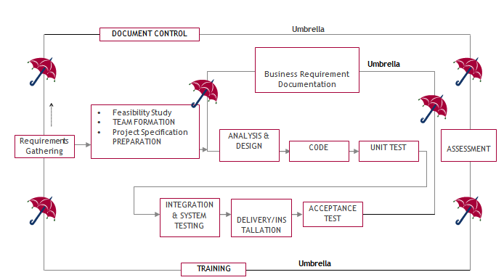
SDLC is nothing but Software Development Life Cycle. It is a standard which is used by software industry to develop good software.
Stages in SDLC:
- Requirement Gathering
- Analysis
- Designing
- Coding
- Testing
- Maintenance
Requirements Gatheringstage:
The requirements gathering process takes as its input the goals identified in the high-level requirements section of the project plan. Each goal will be refined into a set of one or more requirements. These requirements define the major functions of the intended application, define operational data areas and reference data areas, and define the initial data entities. Major functions include critical processes to be managed, as well as mission critical inputs, outputs and reports. A user class hierarchy is developed and associated with these major functions, data areas, and data entities. Each of these definitions is termed a Requirement. Requirements are identified by unique requirement identifiers and, at minimum, contain a requirement title and textual description.
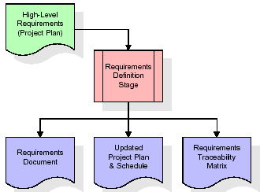
These requirements are fully described in the primary deliverables for this stage: the Requirements Document and the Requirements Traceability Matrix (RTM). The requirements document contains complete descriptions of each requirement, including diagrams and references to external documents as necessary. Note that detailed listings of database tables and fields are not included in the requirements document.
The title of each requirement is also placed into the first version of the RTM, along with the title of each goal from the project plan. The purpose of the RTM is to show that the product components developed during each stage of the software development lifecycle are formally connected to the components developed in prior stages.
In the requirements stage, the RTM consists of a list of high-level requirements, or goals, by title, with a listing of associated requirements for each goal, listed by requirement title. In this hierarchical listing, the RTM shows that each requirement developed during this stage is formally linked to a specific product goal. In this format, each requirement can be traced to a specific product goal, hence the term requirements traceability.
The outputs of the requirements definition stage include the requirements document, the RTM, and an updated project plan.
- Feasibility study is all about identification of problems in a project.
- No. of staff required to handle a project is represented as Team Formation, in this case only modules are individual tasks will be assigned to employees who are working for that project.
- Project Specifications are all about representing of various possible inputs submitting to the server and corresponding outputs along with reports maintained by administrator.
Analysis Stage:
The planning stage establishes a bird's eye view of the intended software product, and uses this to establish the basic project structure, evaluate feasibility and risks associated with the project, and describe appropriate management and technical approaches.
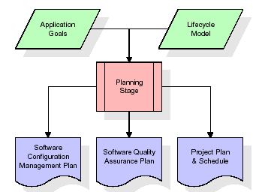
The most critical section of the project plan is a listing of high-level product requirements, also referred to as goals. All of the software product requirements to be developed during the requirements definition stage flow from one or more of these goals. The minimum information for each goal consists of a title and textual description, although additional information and references to external documents may be included. The outputs of the project planning stage are the configuration management plan, the quality assurance plan, and the project plan and schedule, with a detailed listing of scheduled activities for the upcoming Requirements stage, and high level estimates of effort for the out stages.
Designing Stage:
The design stage takes as its initial input the requirements identified in the approved requirements document. For each requirement, a set of one or more design elements will be produced as a result of interviews, workshops, and/or prototype efforts. Design elements describe the desired software features in detail, and generally include functional hierarchy diagrams, screen layout diagrams, tables of business rules, business process diagrams, pseudo code, and a complete entity-relationship diagram with a full data dictionary. These design elements are intended to describe the software in sufficient detail that skilled programmers may develop the software with minimal additional input.
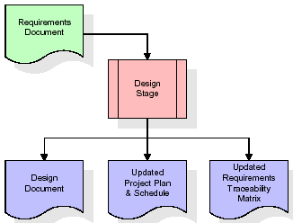
When the design document is finalized and accepted, the RTM is updated to show that each design element is formally associated with a specific requirement. The outputs of the design stage are the design document, an updated RTM, and an updated project plan.
Development (Coding) Stage:
The development stage takes as its primary input the design elements described in the approved design document. For each design element, a set of one or more software artifacts will be produced. Software artifacts include but are not limited to menus, dialogs, and data management forms, data reporting formats, and specialized procedures and functions. Appropriate test cases will be developed for each set of functionally related software artifacts, and an online help system will be developed to guide users in their interactions with the software.
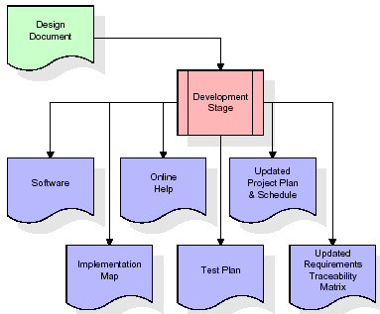

The RTM will be updated to show that each developed artifact is linked to a specific design element, and that each developed artifact has one or more corresponding test case items. At this point, the RTM is in its final configuration. The outputs of the development stage include a fully functional set of software that satisfies the requirements and design elements previously documented, an online help system that describes the operation of the software, an implementation map that identifies the primary code entry points for all major system functions, a test plan that describes the test cases to be used to validate the correctness and completeness of the software, an updated RTM, and an updated project plan.
Integration & Test Stage:
During the integration and test stage, the software artifacts, online help, and test data are migrated from the development environment to a separate test environment. At this point, all test cases are run to verify the correctness and completeness of the software. Successful execution of the test suite confirms a robust and complete migration capability. During this stage, reference data is finalized for production use and production users are identified and linked to their appropriate roles. The final reference data (or links to reference data source files) and production user list are compiled into the Production Initiation Plan.
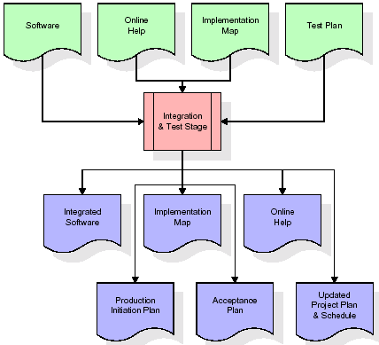
The outputs of the integration and test stage include an integrated set of software, an online help system, an implementation map, a production initiation plan that describes reference data and production users, an acceptance plan which contains the final suite of test cases, and an updated project plan.
- Installation & Acceptance Test:
During the installation and acceptance stage, the software artifacts, online help, and initial production data are loaded onto the production server. At this point, all test cases are run to verify the correctness and completeness of the software. Successful execution of the test suite is a prerequisite to acceptance of the software by the customer.
After customer personnel have verified that the initial production data load is correct and the test suite has been executed with satisfactory results, the customer formally accepts the delivery of the software.
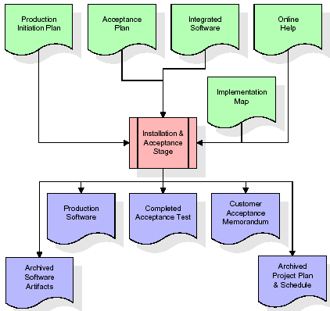
The primary outputs of the installation and acceptance stage include a production application, a completed acceptance test suite, and a memorandum of customer acceptance of the software. Finally, the PDR enters the last of the actual labor data into the project schedule and locks the project as a permanent project record. At this point the PDR "locks" the project by archiving all software items, the implementation map, the source code, and the documentation for future reference.
Maintenance:
Outer rectangle represents maintenance of a project, Maintenance team will start with requirement study, understanding of documentation later employees will be assigned work and they will undergo training on that particular assigned category. For this life cycle there is no end, it will be continued so on like an umbrella (no ending point to umbrella sticks).
3.4. Software Requirement Specification
3.4.1. Overall Description
A Software Requirements Specification (SRS) – a requirements specification for a software system is a complete description of the behaviour of a system to be developed. It includes a set of use cases that describe all the interactions the users will have with the software. In addition to use cases, the SRS also contains non-functional requirements. Non-functional requirements are requirements which impose constraints on the design or implementation (such as performance engineering requirements, quality standards, or design constraints).
System requirements specification: A structured collection of information that embodies the requirements of a system. A business analyst, sometimes titled system analyst, is responsible for analysing the business needs of their clients and stakeholders to help identify business problems and propose solutions. Within the systems development lifecycle domain, the BA typically performs a liaison function between the business side of an enterprise and the information technology department or external service providers. Projects are subject to three sorts of requirements:
- Business requirements describe in business terms what must be delivered or accomplished to provide value.
- Product requirements describe properties of a system or product (which could be one of several ways to accomplish a set of business requirements.)
- Process requirements describe activities performed by the developing organization. For instance, process requirements could specify .Preliminary investigation examine project feasibility, the likelihood the system will be useful to the organization. The main objective of the feasibility study is to test the Technical, Operational and Economical feasibility for adding new modules and debugging old running system. All system is feasible if they are unlimited resources and infinite time. There are aspects in the feasibility study portion of the preliminary investigation:
- ECONOMIC FEASIBILITY
A system can be developed technically and that will be used if installed must still be a good investment for the organization. In the economical feasibility, the development cost in creating the system is evaluated against the ultimate benefit derived from the new systems. Financial benefits must equal or exceed the costs. The system is economically feasible. It does not require any addition hardware or software. Since the interface for this system is developed using the existing resources and technologies available at NIC, There is nominal expenditure and economical feasibility for certain.
- Operational Feasibility
Proposed projects are beneficial only if they can be turned out into information system. That will meet the organization’s operating requirements. Operational feasibility aspects of the project are to be taken as an important part of the project implementation. This system is targeted to be in accordance with the above-mentioned issues. Beforehand, the management issues and user requirements have been taken into consideration. So there is no question of resistance from the users that can undermine the possible application benefits. The well-planned design would ensure the optimal utilization of the computer resources and would help in the improvement of performance status.
- TECHNICAL FEASIBILITY
Earlier no system existed to cater to the needs of ‘Secure Infrastructure Implementation System’. The current system developed is technically feasible. It is a web-based user interface for audit workflow at NIC-CSD. Thus, it provides an easy access to. the users. The database’s purpose is to create, establish and maintain a workflow among various entities in order to facilitate all concerned users in their various capacities or roles. Permission to the users would be granted based on the roles specified. Therefore, it provides the technical guarantee of accuracy, reliability and security.
3.4.2. External Interface Requirements
User Interface
The user interface of this system is a user friendly python Graphical User Interface.
Hardware Interfaces
The interaction between the user and the console is achieved through python capabilities.
Software Interfaces
The required software is python.
SYSTEM REQUIREMENT:
HARDWARE REQUIREMENTS:

Processor - Intel i3(min)
- Speed - 1.1 GHz
- RAM - 4GB(min)
- Hard Disk - 500 GB
SOFTWARE REQUIREMENTS:
- Operating System - Windows10(min)
- Programming Language - Python with Jupiter notebook

4. SYSTEM DESIGN
UML Diagram:
The Unified Modelling Language allows the software engineer to express an analysis model using the modelling notation that is governed by a set of syntactic semantic and pragmatic rules.
A UML system is represented using five different views that describe the system from distinctly different perspective. Each view is defined by a set of diagram, which is as follows.
  - User Model View
    - This view represents the system from the users perspective.
    - The analysis representation describes a usage scenario from the end-users perspective.
  - Structural Model view
    - In this model the data and functionality are arrived from inside the system.
    - This model view models the static structures.
- Behavioural Model View
It represents the dynamic of behavioural as parts of the system, depicting the interactions of collection between various structural elements described in the user model and structural model view.
- Implementation Model View
In this the structural and behavioural as parts of the system are represented as they are to be built.
- Environmental Model View
In this the structural and behavioural aspects of the environment in which the system is to be implemented are represented.
Class Diagram:
The class diagram is the main building block of object oriented modeling. It is used both for general conceptual modeling of the systematic of the application, and for detailed modeling translating the models into programming code. Class diagrams can also be used for data modeling. The classes in a class diagram represent both the main objects, interactions in the application and the classes to be programmed. In the diagram, classes are represented with boxes which contain three parts:
- The upper part holds the name of the class
- The middle part contains the attributes of the class
- The bottom part gives the methods or operations the class can take or undertake.

Use case Diagram:
A use case diagram at its simplest is a representation of a user's interaction with the system and depicting the specifications of a use case. A use case diagram can portray the different types of users of a system and the various ways that they interact with the system. This type of diagram is typically used in conjunction with the textual use case and will often be accompanied by other types of diagrams as well.

Sequence diagram:
A sequence diagram is a kind of interaction diagram that shows how processes operate with one another and in what order. It is a construct of a Message Sequence Chart. A sequence diagram shows object interactions arranged in time sequence. It depicts the objects and classes involved in the scenario and the sequence of messages exchanged between the objects needed to carry out the functionality of the scenario. Sequence diagrams are typically associated with use case realizations in the Logical View of the system under development. Sequence diagrams are sometimes called event diagrams, event scenarios, and timing diagrams.

Collaboration diagram:
A collaboration diagram describes interactions among objects in terms of sequenced messages. Collaboration diagrams represent a combination of information taken from class, sequence, and use case diagrams describing both the static structure and dynamic behaviour of a system.

Component Diagram:
In the Unified Modelling Language, a component diagram depicts how components are wired together to form larger components and or software systems. They are used to illustrate the structure of arbitrarily complex systems.
Components are wired together by using an assembly connector to connect the required interface of one component with the provided interface of another component. This illustrates the service consumer - service provider relationship between the two components.

Deployment Diagram:
A deployment diagram in the Unified Modeling Language models the physical deployment of artifacts on nodes. To describe a web site, for example, a deployment diagram would show what hardware components ("nodes") exist (e.g., a web server, an application server, and a database server), what software components ("artifacts") run on each node (e.g., web application, database), and how the different pieces are connected (e.g. JDBC, REST, RMI).
The nodes appear as boxes, and the artifacts allocated to each node appear as rectangles within the boxes. Nodes may have sub nodes, which appear as nested boxes. A single node in a deployment diagram may conceptually represent multiple physical nodes, such as a cluster of database servers.
Activity Diagram:
Activity diagram is another important diagram in UML to describe dynamic aspects of the system. It is basically a flow chart to represent the flow form one activity to another
activity. The activity can be described as an operation of the system. So the control flow is drawn from one operation to another. This flow can be sequential, branched or concurrent

Upload Dataset
Preprocess Dataset
Calculate Metrices
datasetSplit
datasetSplit
datasetSplit
Cnn Algorithm
MCNN_MDN_model

extension_model
Graph

Data Flow Diagram:
Data flow diagrams illustrate how data is processed by a system in terms of inputs and outputs. Data flow diagrams can be used to provide a clear representation of any business function. The technique starts with an overall picture of the business and continues by analyzing each of the functional areas of interest. This analysis can be carried out in precisely the level of detail required. The technique exploits a method called top-down expansion to conduct the analysis in a targeted way.
As the name suggests, Data Flow Diagram (DFD) is an illustration that explicates the passage of information in a process. A DFD can be easily drawn using simple symbols. Additionally, complicated processes can be easily automated by creating DFDs using easy-to-use, free downloadable diagramming tools. A DFD is a model for constructing and analyzing information processes. DFD illustrates the flow of information in a process depending upon the inputs and outputs. A DFD can also be referred to as a Process Model. A DFD demonstrates business or technical process with the support of the outside data saved, plus the data flowing from the process to another and the end results.

User
1. upload dataset 2.upload dataset successfully
3. preprocess dataset 4.preprocess dataset successfully
5. Run Calculate Metrices 6.Random Calculate Metrices
7. run Cnn Algorithm 8. Run Cnn Algorithm Successfully
9.run MCNN_MDN_model 10. Successfully Run MCNN_MDN_model
11.Run extension_model 12. Successfully run extension_model

system

5. IMPLEMETATION
5.1 PYTHON
* One of the most popular languages is Python. Guido van Rossum released this language in 1991. Python is available on the Mac, Windows, and Raspberry Pi operating systems. The syntax of Python is simple and identical to that of English. When compared to Python, it was seen that the other language requires a few extra lines.
*It is an interpreter-based language because code may be run line by line after it has been written. This implies that rapid prototyping is possible across all platforms. Python is a big language with a free, binary-distributed interpreter standard library.
* It is inferior to maintenance that is conducted and is straightforward to learn. It is an object-oriented, interpreted programming language. It supports several different programming paradigms in addition to object-oriented programming, including functional and procedural programming.
* It supports several different programming paradigms in addition to object-oriented programming, including practical and procedural programming. Python is mighty while maintaining a relatively straightforward syntax. Classes, highly dynamic data types, modules, and exceptions are covered. Python can also be utilised by programmes that require programmable interfaces as an external language.
Here are some key features and characteristics of Python:
- Readability: Python emphasizes code readability with its clean and intuitive syntax. It uses indentation and whitespace to structure code blocks, making it easy to understand and maintain.
- Easy to Learn: Python's simplicity and readability make it an excellent choice for beginners. Its straightforward syntax and extensive documentation make it accessible for newcomers to programming.
- Interpreted Language: Python is an interpreted language, meaning that it doesn't need to be compiled before running. The Python interpreter reads and executes the code directly, making the development process faster and more interactive.
- Cross-platform Compatibility: Python is available for major operating systems like Windows, macOS, and Linux. This cross-platform compatibility allows developers to write code once and run it on different platforms without modifications.
- Large Standard Library: Python comes with a vast standard library that provides ready-to-use modules and functions for various tasks. It covers areas such as file I/O, networking, regular expressions, databases, and more, saving developers time and effort.
- Extensible and Modular: Python supports modular programming, enabling developers to organize code into reusable modules and packages. Additionally, Python allows integrating modules written in other languages, such as C or C++, providing flexibility and performance optimizations.
- Wide Range of Libraries and Frameworks: Python has a vibrant ecosystem with numerous third-party libraries and frameworks. These libraries, such as NumPy, pandas, TensorFlow, and Django, extend Python's capabilities for specific domains, making it a powerful tool for diverse applications.
- Object-Oriented: Python supports object-oriented programming (OOP) principles, allowing developers to create and work with classes and objects. OOP provides a structured approach to code organization, promoting code reuse and modularity.
- Dynamic Typing: Python is dynamically typed, meaning variable types are determined at runtime. Developers do not need to declare variable types explicitly, which enhances flexibility and simplifies code writing.
5.2 Installation
To install Python on your computer, follow these basic steps:
- Step 1: Visit the Python website Go to the official Python website at https://www.python.org/.
- Step 2: Select the operating system Choose the appropriate installer for your operating system. Python supports Windows, macOS, and various Linux distributions. Make sure to select the correct version that matches your operating system.
- Step 3: Check which version of Python is installed; if the 3.7.0 version is not there, uninstall it through the control panel and
- Step 4: Install Python 3.7.0 using Cmd.
- Step 5: Install the all libraries that required to run the project
- Step 6: Run
5.3 Python Features:
- Easy: Because Python is a more accessible and straightforward language, Python programming is easier to learn.
- Interpreted language: Python is an interpreted language, therefore it can be used to examine the code line by line and provide results.
- Open Source: Python is a free online programming language since it is open-source.
- Portable: Python is portable because the same code may be used on several computer standard
- libraries: Python offers a sizable library that we may utilize to create applications quickly.
- GUI: It stands for GUI (Graphical User Interface)
- Dynamical typed: Python is a dynamically typed language, therefore the type of the value will be determined at runtime.
5.4 Python GUI (Tkinter)
- Python provides a wide range of options for GUI development (Graphical User Interfaces).
- Tkinter, the most widely used GUI technique, is used for all of them.
- The Tk GUI toolkit offered by Python is used with the conventional Python interface.
- Tkinter is the easiest and quickest way to write Python GUI programs.
- Using Tkinter, creating a GUI is simple.
- A part of Python's built-in library is Tkinter. The GUI programs were created.
- Python and Tkinter together give a straightforward and quick way. The Tk GUI toolkit's object-oriented user interface is called Tkinter.

Making a GUI application is easy using Tkinter. Following are the steps:
1) Install the Tkinter module in place.
2) The GUI applicatioMakeske the primary window
3) Include one or more of the widgets mentioned above in the GUI application.
4) Set up the main event loop such that it reacts to each user-initiated event.
Although Tkinter is the only GUI framework included in the Python standard library, Python includes a GUI framework. The default library for Python is called Tkinter. Tk is a scripting language often used in designing, testing, and developing GUIs. Tk is a free, open-source widget toolkit that may be used to build GUI applications in a wide range of computer languages.
5.5 Python IDLE
- Python IDLE offers a full-fledged file editor, which gives you the ability to write and execute Python programs from within this program. The built-in file editor also includes several features, like code completion and automatic indentation, that will speed up your coding workflow.
- Guido Van Rossum named Python after the British comedy group Monty Python while the name IDLE was chosen to pay tribute to Eric Idle, who was one of the Monty Python's founding members. IDLE comes bundled with the default implementation of the Python language since the 01.5. 2b1 release
- IDLE is used to execute statements similar to Python Shell. IDLE is used to create, modify, and execute Python code. IDLE provides a fully-featured text editor to write Python scripts and provides features like syntax highlighting, auto-completion, and smart indent.
- IDLE has two modes: interactive and script. We wrote our first program, “Hello, World!” in interactive mode. Interactive mode immediately returns the results of commands you enter into the shell. In script mode, you will write a script and then run it.
- The IDE Python IDLE is a good place to start as it helps you become familiar with the way Python works and understand its syntax. This IDE is good to start programming in Python due to its great debugger, but once you are fluent and start developing projects it is necessary to jump to another, more complete IDE.
- Python IDLE (Integrated Development and Learning Environment) is an interactive development environment included with the Python programming language. It provides a convenient way to write, execute, and debug Python code.
When you install Python, IDLE is typically installed along with it. To open IDLE, you can follow these steps:
- Open the command prompt (Windows) or terminal (macOS/Linux).
- Type "idle" and press Enter. Alternatively, you can specify the version with "idle3" or "idle2" for Python 3 or Python 2, respectively.
- Once IDLE is launched, you will see the Python shell, which is an interactive environment where you can type and execute Python code directly.
Here are some features and functionalities provided by Python IDLE:
- Editor: IDLE includes a text editor where you can write your Python code. It offers syntax highlighting, automatic indentation, and code completion to enhance your coding experience.
- Interactive Shell: The Python shell in IDLE allows you to execute Python code interactively. You can type commands, statements, or function calls directly in the shell, and Python will execute them immediately.
- Debugging: IDLE provides basic debugging capabilities to help you find and fix errors in your code. You can set breakpoints, step through code, inspect variables, and track the program's execution.
- Python Help: IDLE provides access to the Python documentation and built-in help. You can access the help menu to find information about Python modules, functions, classes, and more.
- Script Execution: In addition to the interactive shell, IDLE allows you to run Python scripts stored in files. You can write your code in the editor and execute it as a script to see the output or interact with the program.
- Customization: IDLE can be customized to suit your preferences. You can modify settings related to syntax highlighting, indentation, fonts, and more.
- Python IDLE serves as a beginner-friendly development environment and learning tool. It is suitable for writing small scripts, testing code snippets, experimenting with Python features, and learning the language's basics. However, for more advanced development projects, you may consider using other code editors or integrated development environments (IDEs) that provide additional features and better project management capabilities.
5.6 Libraries
In Python, libraries (also referred to as modules or packages) are collections of pre-written code that provide additional functionality and tools to extend the capabilities of the Python language. Libraries contain reusable code that developers can leverage to perform specific tasks without having to write everything from scratch.
Python libraries are designed to solve common problems, such as handling data, performing mathematical operations, interacting with databases, working with files, implementing networking protocols, creating graphical user interfaces (GUIs), and much more. They provide ready-to-use functions, classes, and methods that simplify complex operations and save development time.
Libraries in Python offer various advantages:
- Code Reusability:
- Efficiency:
- Collaboration
- Domain-Specific Functionality
- To use a Python library, you need to install it first.
There are some libraries following:
- Pandas:
Pandas are a Python computer language library for data analysis and manipulation. It offers a specific operation and data format for handling time series and numerical tables. It differs significantly from the release3-clause of the BSD license. It is a well-liked open-source of opinion that is utilized in machine learning and data analysis.
Pandas are a Python package providing fast, flexible, and expressive data structures designed to make working with “relational” or “labeled” data both easy and intuitive. It aims to be the fundamental high-level building block for doing practical, real-world data analysis in Python. Pandas are a Python library used for working with data sets.
- It has functions for analysing, cleaning, exploring, and manipulating data.
- The name "Pandas" has a reference to both "Panel Data", and "Python Data Analysis" and was created by Wes McKinney in 2008.
- Pandas allow us to analyse big data and make conclusions based on statistical theories.
- Pandas can clean messy data sets, and make them readable and relevant.
Relevant data is very important in data science. Pandas are a Python library for data analysis. Started by Wes McKinney in 2008 out of a need for a powerful and flexible quantitative analysis tool, pandas have grown into one of the most popular Python libraries. It has an extremely active community of contributors. The name is derived from the term "panel data", an econometrics term for data sets that include observations over multiple time periods for the same individuals. Its name is a play on the phrase "Python data analysis" itself.
- NumPy:
The NumPy Python library for multi-dimensional, big-scale matrices adds a huge number of high-level mathematical functions. It is possible to modify NumPy by utilizing a Python library. Along with line, algebra, and the Fourier transform operations, it also contains several matrices-related functions.
NumPy can be used to perform a wide variety of mathematical operations on arrays. It adds powerful data structures to Python that guarantee efficient calculations with arrays and matrices and it supplies an enormous library of high-level mathematical functions that operate on these arrays and matrices.
- NumPy is a Python library used for working with arrays.
- It also has functions for working in domain of linear algebra, Fourier transform, and matrices.
- NumPy was created in 2005 by Travis Oliphant. It is an open source project and you can use it freely.
- NumPy stands for Numerical Python.
- In Python we have lists that serve the purpose of arrays, but they are slow to process.
- NumPy aims to provide an array object that is up to 50x faster than traditional Python lists.
- The array object in NumPy is called ndarray, it provides a lot of supporting functions that make working with ndarray very easy.
- Arrays are very frequently used in data science, where speed and resources are very important.

- Matplotlib:
It is a multi-platform, array-based data visualization framework built to interact with the whole SciPy stack. MATLAB is proposed as an open-source alternative. Matplotlib is a Python extension and a cross-platform toolkit for graphical plotting and visualization.
Matplotlib is a popular Python library for creating static, animated, and interactive visualizations. It provides a flexible and comprehensive set of tools for generating plots, charts, histograms, scatter plots, and more. Matplotlib is widely used in various fields, including data analysis, scientific research, and data visualization.
Here are some key features and functionalities of the Matplotlib library:
- Plotting Functions
- Customization Options
- Multiple Interfaces
- Integration with NumPy and pandas
- Subplots and Figures:
- Saving and Exporting

- Scikit-learn:
The most stable and practical machine learning library for Python is scikit-learn. Regression, dimensionality reduction, classification, and clustering are just a few of the helpful tools it provides through the Python interface for statistical modeling and machine learning. It is an essential part of the Python machine learning toolbox used by JP Morgan. It is frequently used in various machine learning applications, including classification and predictive analysis.
Scikit-learn (also referred to as sklearn) is a widely used open-source machine learning library for Python. It provides a comprehensive set of tools and algorithms for various machine learning tasks, including classification, regression, clustering, dimensionality reduction, model selection, and pre-processing.
Here are some key features and functionalities of the Scikit-learn library:
- Easy-to-Use Interface:
- Broad Range of Algorithms:
- Data Pre-processing and Feature Engineering:
- Model Evaluation and Validation:
- Integration with NumPy and pandas:
- Robust Documentation and Community Support:

- Keras:
* Google's Keras is a cutting-edge deep learning API for creating neural networks. It is created in Python and is designed to simplify the development of neural networks. Additionally, it enables the use of various neural networks for computation. Deep learning models are developed and tested using the free and open-source Python software known as Keras.
Keras is a high-level deep learning library for Python. It is designed to provide a user-friendly and intuitive interface for building and training deep learning models. Keras acts as a front-end API, allowing developers to define and configure neural networks while leveraging the computational backend engines, such as Tensor Flow or Theano.
Here are some key features and functionalities of the Keras library:
- User-Friendly API
- Multi-backend Support
- Wide Range of Neural Network Architectures
- Pre-trained Models and Transfer Learning:
- Easy Model Training and Evaluation:
- GPU Support:

- h5py:
* The h5py Python module offers an interface for the binary HDF5 data format. Thanks to p5py, the top can quickly halt the vast amount of numerical data and alter it using the NumPy library. It employs common syntax for Python, NumPy, and dictionary arrays.
h5py is a Python library that provides a simple and efficient interface for working with datasets and files in the Hierarchical Data Format 5 (HDF5) format. HDF5 is a versatile data format commonly used for storing and managing large volumes of numerical data.
Here are some key features and functionalities of the h5py library:
  - HDF5 File Access
  - Dataset Handling:
  - Group Organization:
  - Attributes:
  - Compatibility with NumPy
  - Performance

- Tensor flow
TensorFlow is a Python library for fast numerical computing created and released by Google. It is a foundation library that can be used to create Deep Learning models directly or by using wrapper libraries that simplify the process built on top of TensorFlow. TensorFlow is an end-to-end open source platform for machine learning. TensorFlow is a rich system for managing all aspects of a machine learning system; however, this class focuses on using a particular TensorFlow API to develop and train machine learning models.
TensorFlow is a popular open-source library for machine learning and deep learning. It provides a comprehensive set of tools, APIs, and computational resources for building and training various types of machine learning models, especially neural networks.
Here are some key features and functionalities of TensorFlow:
- Neural Network Framework:
- Computational Graphs
- Automatic Differentiation
- GPU and TPU Support
- Distributed Computing
- Deployment Capabilities

- Tkinter
Tkinter is an acronym for "Tk interface". Tk was developed as a GUI extension for the Tcl scripting language by John Ousterhout. The first release was in 1991. Tkinter is the de facto way in Python to create Graphical User interfaces (GUIs) and is included in all standard Python Distributions. In fact, it's the only framework built into the Python standard library.
Tkinter is a standard Python library used for creating graphical user interfaces (GUIs). It provides a set of modules and classes that allow you to develop interactive and visually appealing desktop applications.
Here are some key features and functionalities of Tkinter:
- Cross-Platform Compatibility
- Simple and Easy-to-Use
- Widgets and Layout Management
- Event-Driven Programming
- Customization and Styling
- Integration with Other Libraries

- NLTK
NLTK is a toolkit build for working with NLP in Python. It provides us various text processing libraries with a lot of test datasets. A variety of tasks can be performed using NLTK such as tokenizing, parse tree visualization, etc NLTK (Natural Language Toolkit) is the go-to API for NLP (Natural Language Processing) with Python. It is a really powerful tool to pre-process text data for further analysis like with ML models for instance. It helps convert text into numbers, which the model can then easily work with.
NLTK (Natural Language Toolkit) is a Python library widely used for working with human language data and implementing natural language processing (NLP) tasks. It provides a set of tools, corpora, and resources for tasks such as tokenization, stemming, tagging, parsing, sentiment analysis, and more.
Here are some key features and functionalities of NLTK:
- Text Processing
- Part-of-Speech Tagging
- Named Entity Recognition
- Chunking and Parsing
- Sentiment Analysis:
- WordNet Integration:

- Scipy
SciPy is a collection of mathematical algorithms and convenience functions built on the NumPy extension of Python. It adds significant power to the interactive Python session by providing the user with high-level commands and classes for manipulating and visualizing data.
SciPy is a powerful scientific computing library for Python that provides a wide range of mathematical algorithms and functions. It builds upon NumPy, another fundamental library for numerical computing, and extends its capabilities by adding additional tools for scientific and technical computing tasks.
Here are some key features and functionalities of SciPy:
- Numerical Integration:
- Optimization and Root Finding
- Linear Algebra
- Signal and Image Processing
- Statistics
Algorithms Used:
CNN:
Convolutional Neural Network (CNN)
A Convolutional Neural Network (CNN) is a type of Deep Learning neural network architecture commonly used in Computer Vision. Computer vision is a field of Artificial Intelligence that enables a computer to understand and interpret the image or visual data.
When it comes to Machine Learning, Artificial Neural Networks perform really well. Neural Networks are used in various datasets like images, audio, and text. Different types of Neural Networks are used for different purposes, for example for predicting the sequence of words we use Recurrent Neural Networks more precisely an LSTM, similarly for image classification we use Convolution Neural networks. In this blog, we are going to build a basic building block for CNN.
In a regular Neural Network there are three types of layers:
- Input Layers: It’s the layer in which we give input to our model. The number of neurons in this layer is equal to the total number of features in our data (number of pixels in the case of an image).
- Hidden Layer: The input from the Input layer is then fed into the hidden layer. There can be many hidden layers depending on our model and data size. Each hidden layer can have different numbers of neurons which are generally greater than the number of features. The output from each layer is computed by matrix multiplication of the output of the previous layer with learnable weights of that layer and then by the addition of learnable biases followed by activation function which makes the network nonlinear.
- Output Layer: The output from the hidden layer is then fed into a logistic function like sigmoid or softmax which converts the output of each class into the probability score of each class.
The data is fed into the model and output from each layer is obtained from the above step is called feedforward, we then calculate the error using an error function, some common error functions are cross-entropy, square loss error, etc. The error function measures how well the network is performing. After that, we backpropagate into the model by calculating the derivatives. This step is called Backprzopagation which basically is used to minimize the loss.

Convolution Neural Network
Convolutional Neural Network (CNN) is the extended version of artificial neural networks (ANN) which is predominantly used to extract the feature from the grid-like matrix dataset. For example visual datasets like images or videos where data patterns play an extensive role.

CNN architecture
Convolutional Neural Network consists of multiple layers like the input layer, Convolutional layer, Pooling layer, and fully connected layers.
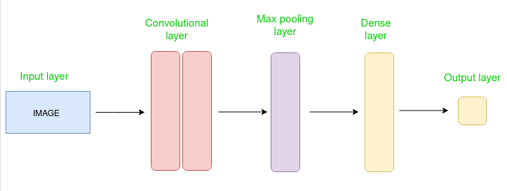
Simple CNN architecture
The Convolutional layer applies filters to the input image to extract features, the Pooling layer downsamples the image to reduce computation, and the fully connected layer makes the final prediction. The network learns the optimal filters through backpropagation and gradient descent.

How Convolutional Layers works
Convolution Neural Networks or covnets are neural networks that share their parameters. Imagine you have an image. It can be represented as a cuboid having its length, width (dimension of the image), and height (i.e the channel as images generally have red, green, and blue channels).
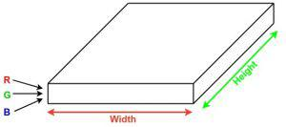
Now imagine taking a small patch of this image and running a small neural network, called a filter or kernel on it, with say, K outputs and representing them vertically. Now slide that neural network across the whole image, as a result, we will get another image with different widths, heights, and depths. Instead of just R, G, and B channels now we have more channels but lesser width and height. This operation is called Convolution. If the patch size is the same as that of the image it will be a regular neural network. Because of this small patch, we have fewer weights.
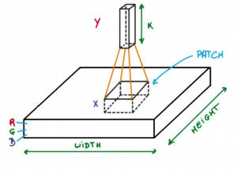
Image source: Deep Learning Udacity
Now let’s talk about a bit of mathematics that is involved in the whole convolution process.
- Convolution layers consist of a set of learnable filters (or kernels) having small widths and heights and the same depth as that of input volume (3 if the input layer is image input).
- For example, if we have to run convolution on an image with dimensions 34x34x3. The possible size of filters can be axax3, where ‘a’ can be anything like 3, 5, or 7 but smaller as compared to the image dimension.
- During the forward pass, we slide each filter across the whole input volume step by step where each step is called stride (which can have a value of 2, 3, or even 4 for high-dimensional images) and compute the dot product between the kernel weights and patch from input volume.
- As we slide our filters we’ll get a 2-D output for each filter and we’ll stack them together as a result, we’ll get output volume having a depth equal to the number of filters. The network will learn all the filters.

Layers used to build ConvNets
A complete Convolution Neural Networks architecture is also known as covnets. A covnets is a sequence of layers, and every layer transforms one volume to another through a differentiable function.
Types of layers:
datasets
Let’s take an example by running a covnets on of image of dimension 32 x 32 x 3.
- Input Layers: It’s the layer in which we give input to our model. In CNN, Generally, the input will be an image or a sequence of images. This layer holds the raw input of the image with width 32, height 32, and depth 3.
- Convolutional Layers: This is the layer, which is used to extract the feature from the input dataset. It applies a set of learnable filters known as the kernels to the input images. The filters/kernels are smaller matrices usually 2×2, 3×3, or 5×5 shape. it slides over the input image data and computes the dot product between kernel weight and the corresponding input image patch. The output of this layer is referred as feature maps. Suppose we use a total of 12 filters for this layer we’ll get an output volume of dimension 32 x 32 x 12.
- Activation Layer: By adding an activation function to the output of the preceding layer, activation layers add nonlinearity to the network. it will apply an element-wise activation function to the output of the convolution layer. Some common activation functions are RELU: max(0, x), Tanh, Leaky RELU, etc. The volume remains unchanged hence output volume will have dimensions 32 x 32 x 12.
- Pooling layer: This layer is periodically inserted in the covnets and its main function is to reduce the size of volume which makes the computation fast reduces memory and also prevents overfitting. Two common types of pooling layers are max pooling and average pooling. If we use a max pool with 2 x 2 filters and stride 2, the resultant volume will be of dimension 16x16x12.
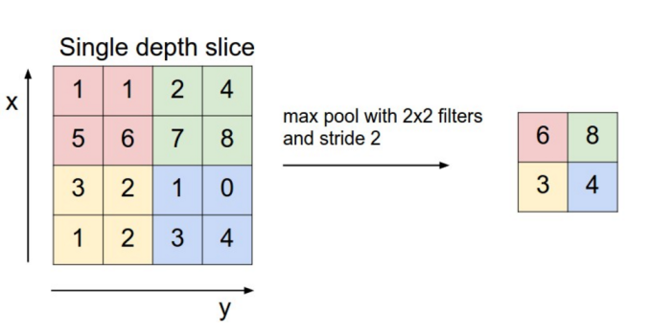
Image source: cs231n.stanford.edu
- Flattening: The resulting feature maps are flattened into a one-dimensional vector after the convolution and pooling layers so they can be passed into a completely linked layer for categorization or regression.
- Fully Connected Layers: It takes the input from the previous layer and computes the final classification or regression task.
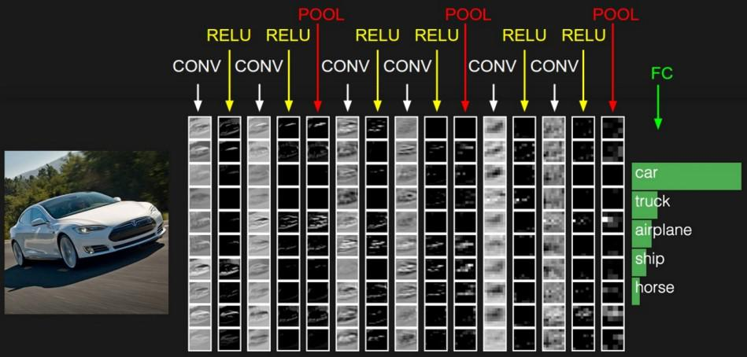
- Output Layer: The output from the fully connected layers is then fed into a logistic function for classification tasks like sigmoid or softmax which converts the output of each class into the probability score of each class.

Example:
Let’s consider an image and apply the convolution layer, activation layer, and pooling layer operation to extract the inside feature.
Input image:

Input image

Step:
- import the necessary libraries
- set the parameter
- define the kernel
- Load the image and plot it.
- Reformat the image
- Apply convolution layer operation and plot the output image.
- Apply activation layer operation and plot the output image.
- Apply pooling layer operation and plot the output image.

Python3
# import the necessary libraries
import numpy as np
import tensorflow as tf
import matplotlib.pyplot as plt
from itertools import product
# set the param
plt.rc('figure', autolayout=True)
plt.rc('image', cmap='magma')

# define the kernel
kernel = tf.constant([[-1, -1, -1],
[-1, 8, -1],
[-1, -1, -1],
])

# load the image
image = tf.io.read_file('Ganesh.jpg')
image = tf.io.decode_jpeg(image, channels=1)
image = tf.image.resize(image, size=[300, 300])

# plot the image
img = tf.squeeze(image).numpy()
plt.figure(figsize=(5, 5))
plt.imshow(img, cmap='gray')
plt.axis('off')
plt.title('Original Gray Scale image')
plt.show();

# Reformat
image = tf.image.convert_image_dtype(image, dtype=tf.float32)
image = tf.expand_dims(image, axis=0)
kernel = tf.reshape(kernel, [*kernel.shape, 1, 1])
kernel = tf.cast(kernel, dtype=tf.float32)

# convolution layer
conv_fn = tf.nn.conv2d

image_filter = conv_fn(
input=image,
filters=kernel,
strides=1, # or (1, 1)
padding='SAME',
)

plt.figure(figsize=(15, 5))

# Plot the convolved image
plt.subplot(1, 3, 1)

plt.imshow(
tf.squeeze(image_filter)
)
plt.axis('off')
plt.title('Convolution')

# activation layer
relu_fn = tf.nn.relu
# Image detection
image_detect = relu_fn(image_filter)

plt.subplot(1, 3, 2)
plt.imshow(
# Reformat for plotting
tf.squeeze(image_detect)
)

plt.axis('off')
plt.title('Activation')

# Pooling layer
pool = tf.nn.pool
image_condense = pool(input=image_detect,
window_shape=(2, 2),
pooling_type='MAX',
strides=(2, 2),
padding='SAME',
)

plt.subplot(1, 3, 3)
plt.imshow(tf.squeeze(image_condense))
plt.axis('off')
plt.title('Pooling')
plt.show()
Output:

Original Grayscale image
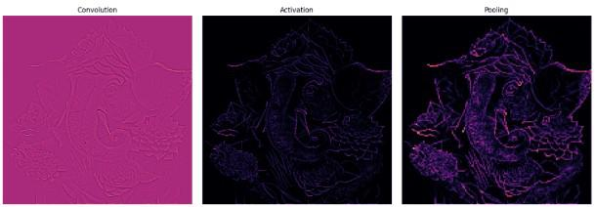
5.2 Sample Code:
#import python classes and packages
from keras.utils.np_utils import to_categorical
from keras.models import Sequential, load_model
#loading CNN3D classes
from keras.layers import Conv3D, MaxPool3D, Flatten, Dense, InputLayer, BatchNormalization, Dropout, GlobalAveragePooling3D, MaxPooling2D
from sklearn.metrics import accuracy_score
from sklearn.model_selection import train_test_split
from keras.callbacks import ModelCheckpoint
import pandas as pd
from keras import layers
import numpy as np
import keras
import os
from keras.layers import Convolution2D
import pickle
from keras.layers import Bidirectional, GRU, Conv1D, MaxPooling1D, RepeatVector#loading GRU, bidriectional, and CNN
import seaborn as sns
from sklearn.metrics import precision_score
from sklearn.metrics import recall_score
from sklearn.metrics import f1_score
from sklearn.metrics import confusion_matrix
import matplotlib.pyplot as plt
#defining class labels
labels = ['Walking', 'Upstairs', 'Downstairs', 'Sitting', 'Standing', 'Laying']
#loading UCI Har dataset captured activities from smart phones
X = pd.read_csv("Dataset/X_train.txt", header=None, delim_whitespace=True)
Y = pd.read_csv("Dataset/y_train.txt", header=None, delim_whitespace=True)
X#visualizing class labels count found in dataset
names, count = np.unique(Y, return_counts = True)
height = count
bars = labels
y_pos = np.arange(len(bars))
plt.figure(figsize = (4, 3)) plt.bar(y_pos, height)plt.xticks(y_pos, bars)plt.xlabel("Dataset Class Label Graph")plt.ylabel("Count")plt.xticks(rotation=90)plt.show()#features processing, shuffling and splitting dataset into train and testX = X.valuesY = Y.valuesindices = np.arange(X.shape[0])np.random.shuffle(indices)X = X[indices]Y = Y[indices]Y = to_categorical(Y)X = np.reshape(X, (X.shape[0], 17, 11, 3, 1))X_train, X_test, y_train, y_test = train_test_split(X, Y, test_size=0.2) #split dataset into train and testprint()print("Dataset train & test split as 80% dataset for training and 20% for testing")print("Training Size (80%): "+str(X_train.shape[0])) #print training and test sizeprint("Testing Size (20%): "+str(X_test.shape[0]))print()#define global variables to calculate and store accuracy and other metricsprecision = []recall = []fscore = []accuracy = []#function to calculate various metrics such as accuracy, precision etc
def calculateMetrics(algorithm, predict, testY): p = precision_score(testY, predict,average='macro') * 100 r = recall_score(testY, predict,average='macro') * 100 f = f1_score(testY, predict,average='macro') * 100 a = accuracy_score(testY,predict)*100 print(algorithm+' Accuracy : '+str(a)) print(algorithm+' Precision : '+str(p)) print(algorithm+' Recall : '+str(r)) print(algorithm+' FMeasure : '+str(f)) accuracy.append(a) precision.append(p) recall.append(r) fscore.append(f) conf_matrix = confusion_matrix(testY, predict) plt.figure(figsize =(4, 3)) ax = sns.heatmap(conf_matrix, xticklabels = labels, yticklabels = labels, annot = True, cmap="viridis" ,fmt ="g"); ax.set_ylim([0,len(labels)]) plt.title(algorithm+" Confusion matrix") plt.ylabel('True class') plt.xlabel('Predicted class')
plt.show()
#train existing CNN algorithm which will use many parameters for training and can increase computation complexity
X_train1 = np.reshape(X_train, (X_train.shape[0], X_train.shape[1], X_train.shape[2], (X_train.shape[3] * X_train.shape[4])))
X_test1 = np.reshape(X_test, (X_test.shape[0], X_test.shape[1], X_test.shape[2], (X_test.shape[3] * X_test.shape[4])))
cnn_model = Sequential()
#define cnn2d layer with 3 number of inout neurons and to filter dataset features
cnn_model.add(Convolution2D(3, (1 , 1), input_shape = (X_train1.shape[1], X_train1.shape[2], X_train1.shape[3]), activation = 'relu'))
#collect filtered features from CNN2D layer
cnn_model.add(MaxPooling2D(pool_size = (1, 1)))
#defining another layer t further optimize features
cnn_model.add(Convolution2D(3, (1, 1), activation = 'relu'))
cnn_model.add(MaxPooling2D(pool_size = (1, 1)))
cnn_model.add(Flatten())
#define output layer
cnn_model.add(Dense(units = 16, activation = 'relu'))
cnn_model.add(Dense(units = y_train.shape[1], activation = 'softmax'))
#compile and train the model
cnn_model.compile(optimizer = 'adam', loss = 'categorical_crossentropy', metrics = ['accuracy'])
print(cnn_model.summary())
if os.path.exists("model/cnn_weights.hdf5") == False:
model_check_point = ModelCheckpoint(filepath='model/cnn_weights.hdf5', verbose = 1, save_best_only = True)
hist = cnn_model.fit(X_train1, y_train1, batch_size = 200, epochs = 20, validation_data=(X_test1, y_test), callbacks=[model_check_point], verbose=1)
f = open('model/cnn_history.pckl', 'wb')
pickle.dump(hist.history, f)
f.close()
else:
cnn_model.load_weights("model/cnn_weights.hdf5")#perform prediction on human behaviour on test data using CNN existing model
predict = cnn_model.predict(X_test1)
predict = np.argmax(predict, axis=1)
y_test1 = np.argmax(y_test, axis=1)
calculateMetrics("Existing CNN Model", predict, y_test1)#train propose CNN3D model which will optimize model using space-time (ST) interaction module
#of matrix operation and the depth separable convolution module. CNN3D is light in training whichreduces the
#computational complexity of output weights and improves the compactness of the model structure. Propose algorithm also known
#as MDN or MCNN
#defining input shape
inputs = keras.Input((X_train.shape[1], X_train.shape[2], X_train.shape[3], X_train.shape[4]))
x = layers.Conv3D(filters=7, kernel_size=3,activation="relu")(inputs)#creating CNN3D layer with 7 neurons for data filter
x = layers.MaxPool3D(pool_size=1)(x) #pool layer to collect filterd features from CNN3D layer
x = layers.BatchNormalization()(x) #normalizing features
x = layers.Conv3D(filters=7, kernel_size=1, activation="relu")(x)#another layer to optimze module using space time
x = layers.MaxPool3D(pool_size=1)(x)
x = layers.BatchNormalization()(x)
x = layers.Conv3D(filters=7, kernel_size=1, activation="relu")(x)
x = layers.MaxPool3D(pool_size=1)(x)
x = layers.BatchNormalization()(x)
x = layers.Conv3D(filters=32, kernel_size=1, activation="relu")(x)#cnn layer for separable convolution module
x = layers.MaxPool3D(pool_size=1)(x)
x = layers.BatchNormalization()(x)
x = layers.GlobalAveragePooling3D()(x)#defining global average pooling
x = layers.Dense(units=64, activation="relu")(x)
x = layers.Dropout(0.3)(x)
outputs = layers.Dense(units=y_train.shape[1], activation="softmax")(x)
mdn_model = keras.Model(inputs, outputs, name="3dcnn") #create model
mdn_model.compile(optimizer = 'adam', loss = 'categorical_crossentropy', metrics = ['accuracy'])
#displaying propose model complexity
print(mdn_model.summary())
if os.path.exists("model/mdn_weights.hdf5") == False:
model_check_point = ModelCheckpoint(filepath='model/mdn_weights.hdf5', verbose = 1, save_best_only = True)
hist = mdn_model.fit(X_train, y_train, batch_size = 32, epochs = 20, validation_data=(X_test, y_test), callbacks=[model_check_point], verbose=1)
f = open('model/mdn_history.pckl', 'wb')
pickle.dump(hist.history, f)
f.close()
else:
mdn_model.load_weights("model/mdn_weights.hdf5")#perform prediction on test data using propose MDN model
predict = mdn_model.predict(X_test)
predict = np.argmax(predict, axis=1)
y_test1 = np.argmax(y_test, axis=1)#calculate metrics
calculateMetrics("Propose MDN Model", predict, y_test1)#train extension hybrid model which is a combination ov CNN1 + Bidirectional + GRU and this model will optimize
#features using 3 differnet models which can help in better prediction accuracy
extension_model = Sequential()
extension_model.add(Convolution2D(2, (1 , 1), input_shape = (X_train.shape[1], X_train.shape[2], X_train.shape[3]), activation = 'relu'))
extension_model.add(MaxPooling2D(pool_size = (1, 1)))
extension_model.add(Convolution2D(1, (1, 1), activation = 'relu'))
extension_model.add(MaxPooling2D(pool_size = (1, 1)))
extension_model.add(Flatten())
extension_model.add(RepeatVector(2))
#adding bidirectional + GRU to CNN layer
extension_model.add(Bidirectional(GRU(1, activation = 'relu')))
extension_model.add(Dense(units = 1, activation = 'relu'))
extension_model.add(Dense(units = y_train.shape[1], activation = 'softmax'))
#compile and train the model
extension_model.compile(optimizer = 'adam', loss = 'categorical_crossentropy', metrics = ['accuracy'])
print(extension_model.summary())
if os.path.exists("model/extension_weights.hdf5") == False:
model_check_point = ModelCheckpoint(filepath='model/extension_weights.hdf5', verbose = 1, save_best_only = True)
hist = extension_model.fit(X_train, y_train, batch_size = 32, epochs = 20, validation_data=(X_test, y_test), callbacks=[model_check_point], verbose=1)
f = open('model/extension_history.pckl', 'wb')
pickle.dump(hist.history, f)
f.close()
else:
extension_model = load_model("model/extension_weights.hdf5")
#perform prediction on test data using extension model
predict = extension_model.predict(X_test1)
predict = np.argmax(predict, axis=1)
y_test1 = np.argmax(y_test, axis=1)
calculateMetrics("Extension Hybrid Model CNN + GRU + Bidirectional", predict, y_test1)def values(filename, acc, loss):
f = open(filename, 'rb')
train_values = pickle.load(f)
f.close()
accuracy_value = train_values[acc]
loss_value = train_values[loss]
return accuracy_value, loss_valuedf = pd.DataFrame([['Existing CNN2D','Accuracy',accuracy[0]],['Existing CNN2D','Precision',precision[0]],['Existing CNN2D','Recall',recall[0]],['Existing CNN2D','FSCORE',fscore[0]],
['Propose MDN CNN3D','Accuracy',accuracy[1]],['Propose MDN CNN3D','Precision',precision[1]],['Propose MDN CNN3D','Recall',recall[1]],['Propose MDN CNN3D','FSCORE',fscore[1]],
['Extension CNN + Bidirectional + GRU','Accuracy',accuracy[2]],['Extension CNN + Bidirectional + GRU','Precision',precision[2]],['Extension CNN + Bidirectional + GRU','Recall',recall[2]],['Extension CNN + Bidirectional + GRU','FSCORE',fscore[2]],
],columns=['Parameters','Algorithms','Value'])
df.pivot("Parameters", "Algorithms", "Value").plot(kind='bar', figsize=(6, 2))
plt.title("All Algorithms Performance Graph")plt.show()#display all algorithm performnacealgorithms = ['Existing CNN2D Model', 'Propose MDN CNN3D', 'Extension Hybrid CNN + Bidirectional + GRU Model']data = []for i in range(len(accuracy)): data.append([algorithms[i], accuracy[i], precision[i], recall[i], fscore[i]])
data = pd.DataFrame(data, columns=['Algorithm Name', 'Accuracy', 'Precision', 'Recall', 'FSCORE'])
data #loading test behaviour data
testData = pd.read_csv("Dataset/X_test.txt", header=None, delim_whitespace=True)
testData = testData.values
indices = np.arange(testData.shape[0])
np.random.shuffle(indices)#shuffling test data to select random 10 records
testData = testData[indices]
testData = testData[0:10,0:testData.shape[1]]#select 10 records
testData1 = np.reshape(testData, (testData.shape[0], 17, 11, 3)) #convert test data as per CNN model
predict = extension_model.predict(testData1)#perform prediction on test dtaa
for i in range(len(predict)):
pred = np.argmax(predict[i])
print("Test Data : "+str(testData[i][0:30])+" Predicted Activity ===> "+labels[pred-1]+"\n")
6. TESTING
Implementation and Testing:
Implementation is one of the most important tasks in project is the phase in which one has to be cautions because all the efforts undertaken during the project will be very interactive. Implementation is the most crucial stage in achieving successful system and giving the users confidence that the new system is workable and effective. Each program is tested individually at the time of development using the sample data and has verified that these programs link together in the way specified in the program specification. The computer system and its environment are tested to the satisfaction of the user.

Implementation

The implementation phase is less creative than system design. It is primarily concerned with user training, and file conversion. The system may be requiring extensive user training. The initial parameters of the system should be modifies as a result of a programming. A simple operating procedure is provided so that the user can understand the different functions clearly and quickly. The different reports can be obtained either on the inkjet or dot matrix printer, which is available at the disposal of the user. The proposed system is very easy to implement. In general implementation is used to mean the process of converting a new or revised system design into an operational one.

Testing
Testing is the process where the test data is prepared and is used for testing the modules individually and later the validation given for the fields. Then the system testing takes place which makes sure that all components of the system property functions as a unit. The test data should be chosen such that it passed through all possible condition. Actually testing is the state of implementation which aimed at ensuring that the system works accurately and efficiently before the actual operation commence. The following is the description of the testing strategies, which were carried out during the testing period.

System Testing
Testing has become an integral part of any system or project especially in the field of information technology. The importance of testing is a method of justifying, if one is ready to move further, be it to be check if one is capable to with stand the rigors of a particular situation cannot be underplayed and that is why testing before development is so critical. When the software is developed before it is given to user to use the software must be tested whether it is solving the purpose for which it is developed. This testing involves various types through which one can ensure the software is reliable. The program was tested logically and pattern of execution of the program for a set of data are repeated. Thus the code was exhaustively checked for all possible correct data and the outcomes were also checked.

Module Testing
To locate errors, each module is tested individually. This enables us to detect error and correct it without affecting any other modules. Whenever the program is not satisfying the required function, it must be corrected to get the required result. Thus all the modules are individually tested from bottom up starting with the smallest and lowest modules and proceeding to the next level. Each module in the system is tested separately. For example the job classification module is tested separately. This module is tested with different job and its approximate execution time and the result of the test is compared with the results that are prepared manually. The comparison shows that the results proposed system works efficiently than the existing system. Each module in the system is tested separately. In this system the resource classification and job scheduling modules are tested separately and their corresponding results are obtained which reduces the process waiting time.
Integration Testing
After the module testing, the integration testing is applied. When linking the modules there may be chance for errors to occur, these errors are corrected by using this testing. In this system all modules are connected and tested. The testing results are very correct. Thus the mapping of jobs with resources is done correctly by the system.
Acceptance Testing
When that user fined no major problems with its accuracy, the system passers through a final acceptance test. This test confirms that the system needs the original goals, objectives and requirements established during analysis without actual execution which elimination wastage of time and money acceptance tests on the shoulders of users and management, it is finally acceptable and ready for the operation
Test Case Id | Test Case Name | Test Case Desc. | Test Steps |  |  | Test Case Status | Test Priority
 |  |  | Step | Expected | Actual
01 | Upload Dataset | Test whether Dataset is uploaded or not into the system | If the Dataset may not uploaded | We cannot do further operations | Water Quality Dataset uploaded we will do further operations | High | High
02 | Preprocess& Normalized Dataset | Test whether the Pre-process & Normalized Dataset Successfully or not | If the Pre-process & Normalized Dataset may not Run Successfully | We cannot do further operations | we will do further  operations | High | High
03 | Run Calculate Metrices | Test whether Calculate Metrices Algorithm Run Successfully or not | If the  Calculate Metrices Algorithm may not Run Successfully | We cannot do further operations | we will do further  operations | High | High
04 | Train run CNN Algorithm | Test whether CNN Algorithm Run Successfully or not | If the  CNN Algorithm may not Run Successfully | We cannot do further operations | we will do further  operations | High | High
05 | Train run MCNN_MDN_model | Test whether MCNN_MDN_model Run Successfully or not | If the  MCNN_MDN_model Algorithm may not Run Successfully | We cannot do further operations | we will do further  operations | High | High
06 | graph | Test graph whether Successfully or not | If the  graph may not Successfully | We cannot do further operations | we will do further  operations | High | High

7.SCREENSHOTS:
To Run the application Click on “run.bat” file from the file location.

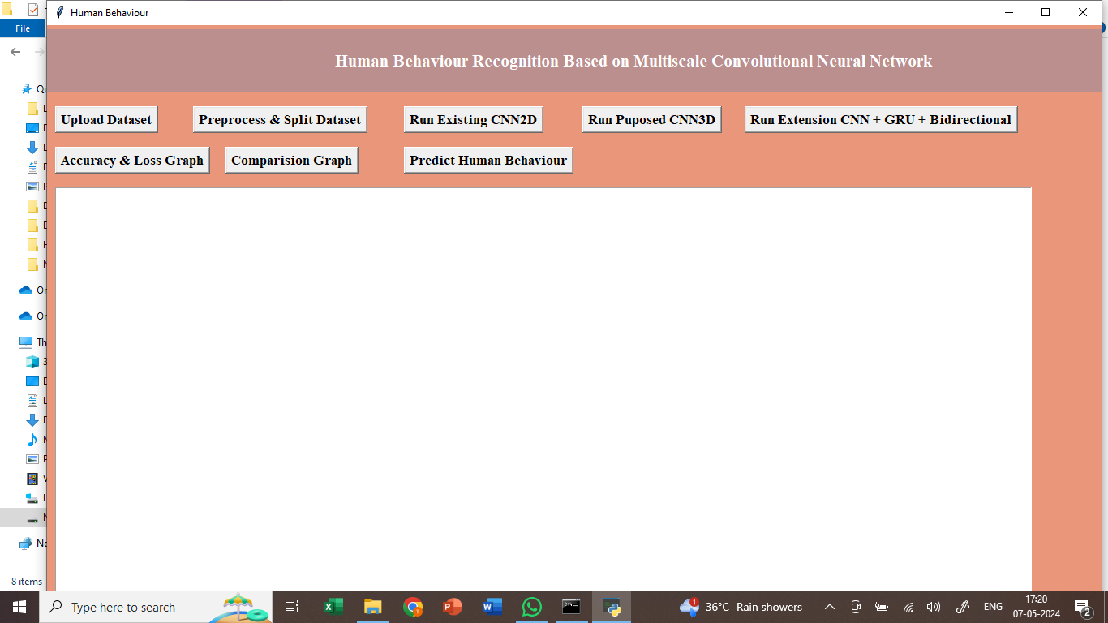
In the above screen we got Tkinter Output Window. Now Click On the “Upload Dataset” button to upload the dataset to the application.
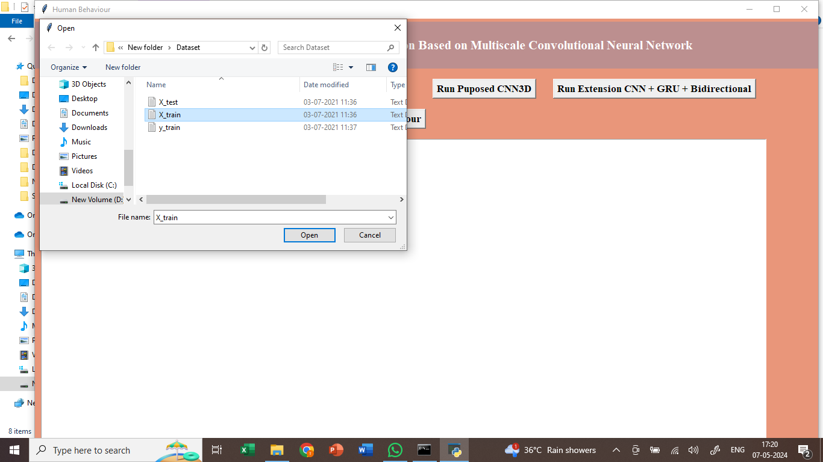
In the above screen we can see the dataset uploading.
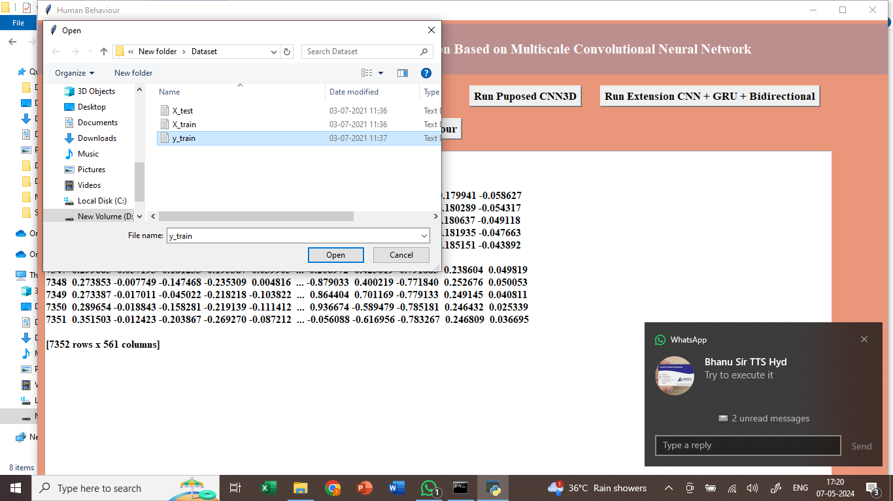
In above screen loading and displaying HAR dataset values captured from smart phone
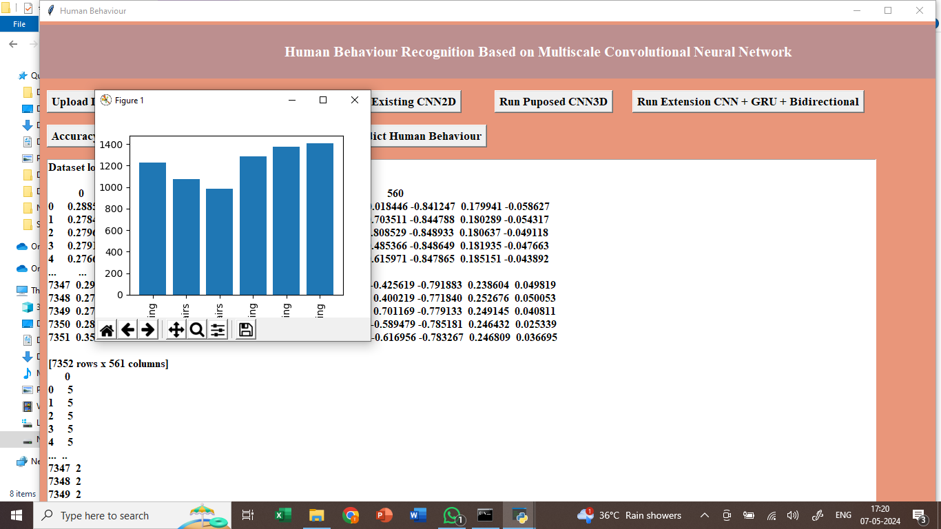
In above screen finding and plotting graph of different activities found in dataset where x-axis represents ACTIVITY NAMES and y-axis represents count of those activities
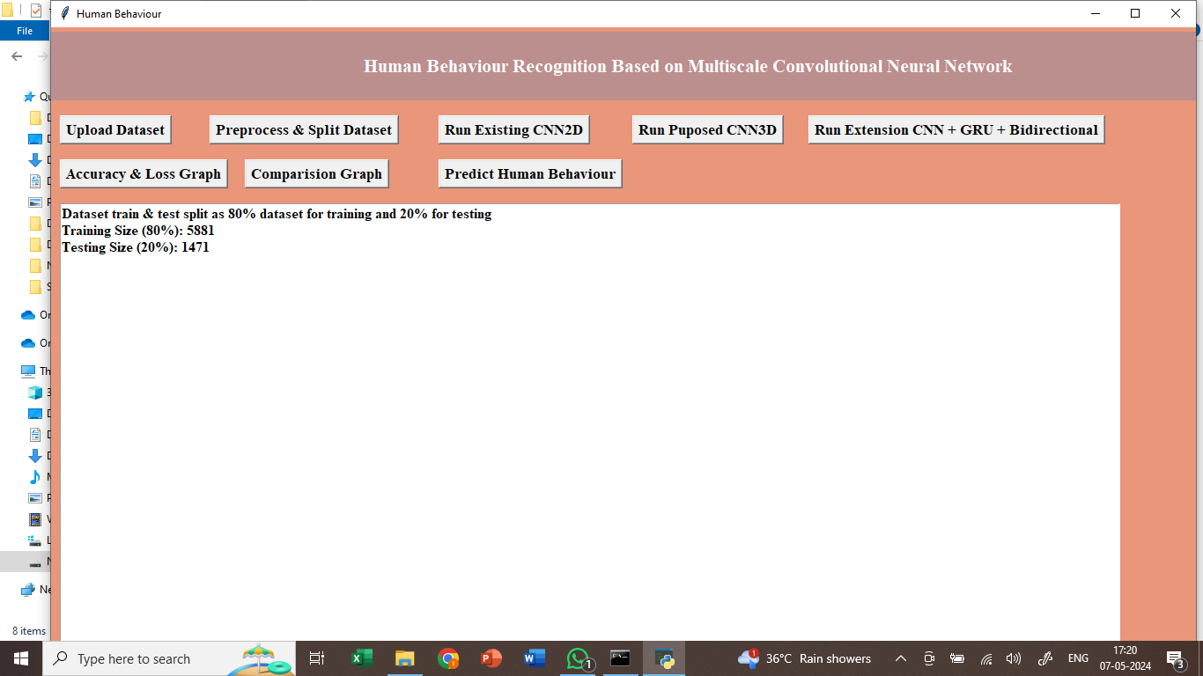
In above screen processing dataset and then splitting dataset into train and test and then can see total records used for training and testing.
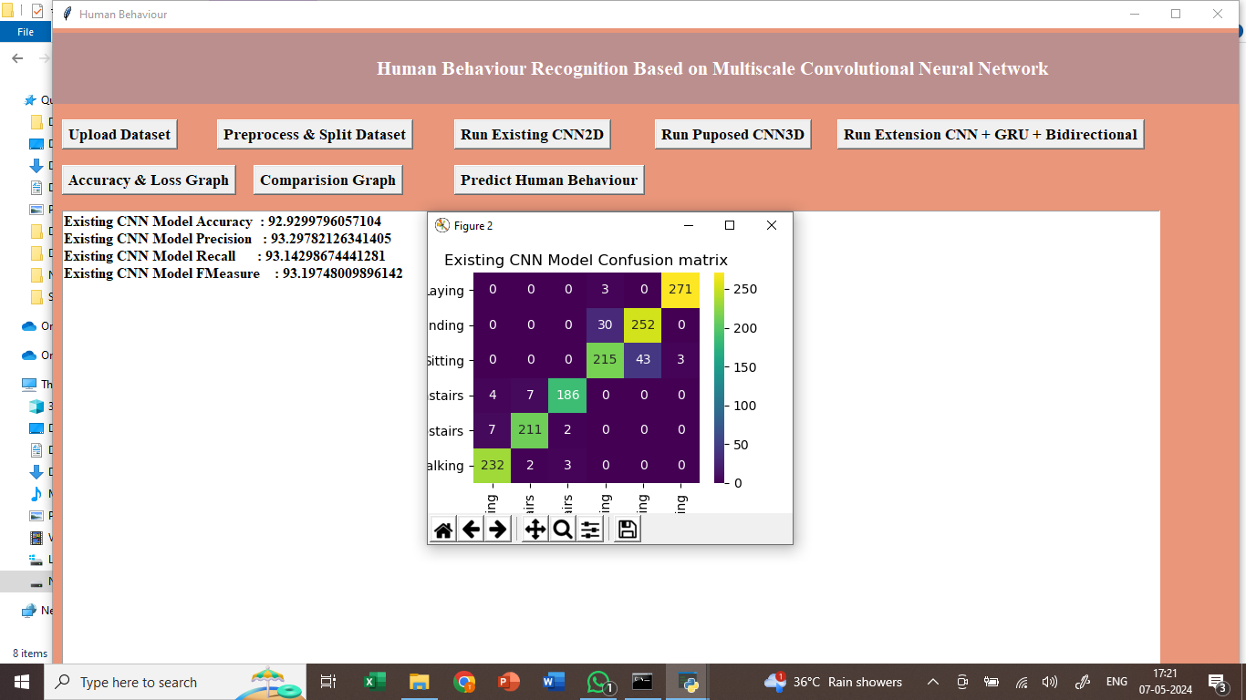
In above screen training existing CNN2D algorithm and can read blue colour comments to know about module and after executing above block will get below complexity of the model. In black console we can see existing CNN2D required 9135 parameters to train a model and increasing this parameters size can increase model complexity and training time and by decreasing we can reduce and in below screen we are performing prediction on test data. In above screen existing CNN2D model got 92% accuracy and can see other metrics and in confusion matrix x-axis represents predicted Labels and y-axis represents True Labels and all blue colour boxes represents incorrect prediction count and different colour boxes represents correct prediction count.
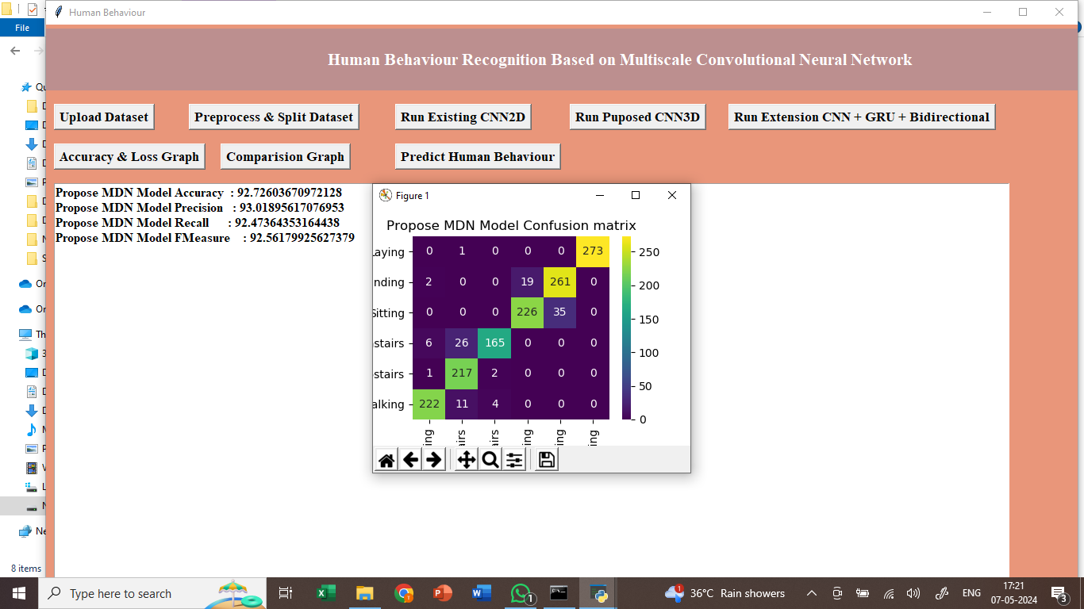
In above screen training propose MCNN (MDN) model using CNN3D architecture and after executing above model will get output . In the black console propose model required 3306 parameters for training which are lesser than existing CNN2D 9000 training parameters and below is the propose model accuracy. Propose MCNN MDN model got 94% accuracy and can see other metrics also.
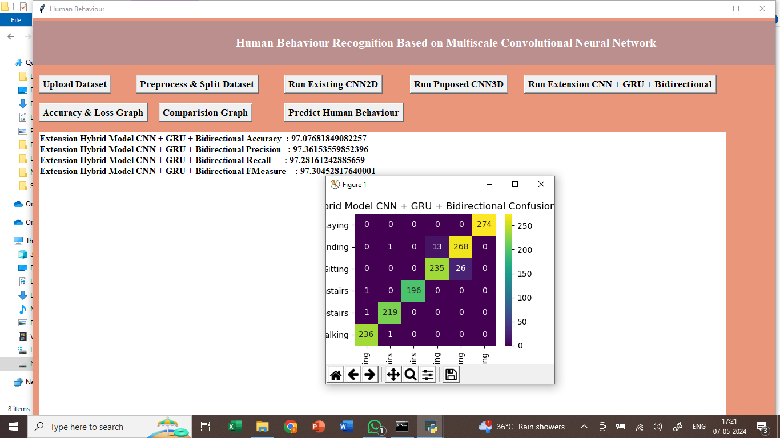
In above screen training extension model by combining 3 different algorithms such as CNN + GRU + Bidirectional and after executing above block will get output. In the black console extension model required 1162 parameters for training which are lesser than propose and existing models and below is the accuracy. Extension model got 96% accuracy and we can see the other metrics also.
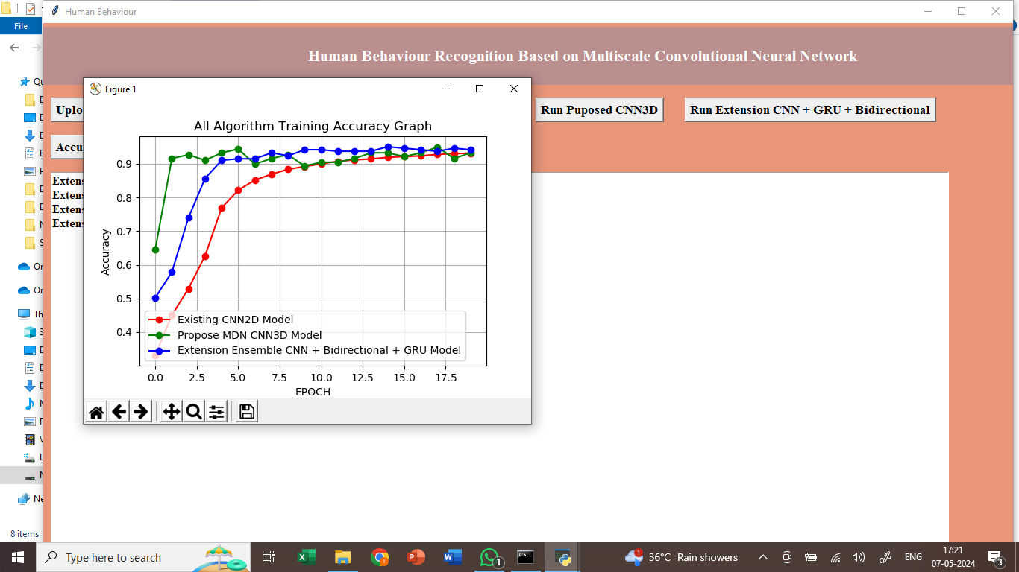
In above screen displaying training accuracy of all 3 models such as existing , propose and extension where x-axis represents training epoch and y-axis represents accuracy and with each increasing epoch accuracy got increase and in in all models extension got high accuracy.
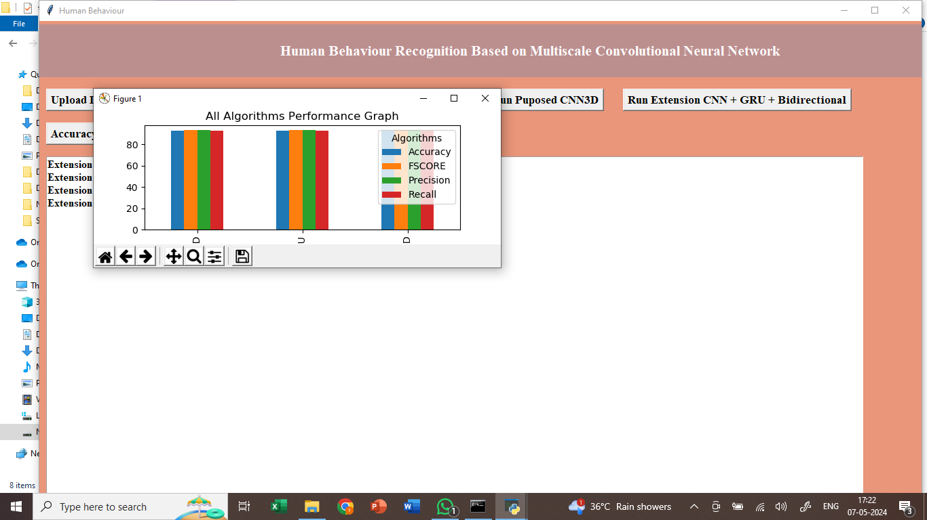
In above comparison graph x-axis represents algorithm names and y-axis represents accuracy and other metrics in different colour bars and in all algorithms extension got high performance.
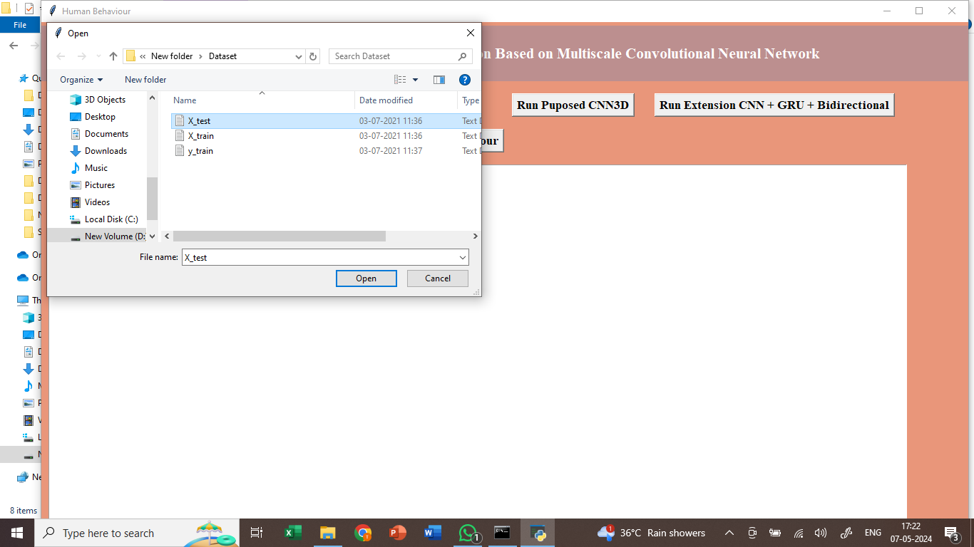
In above screen loading test data .
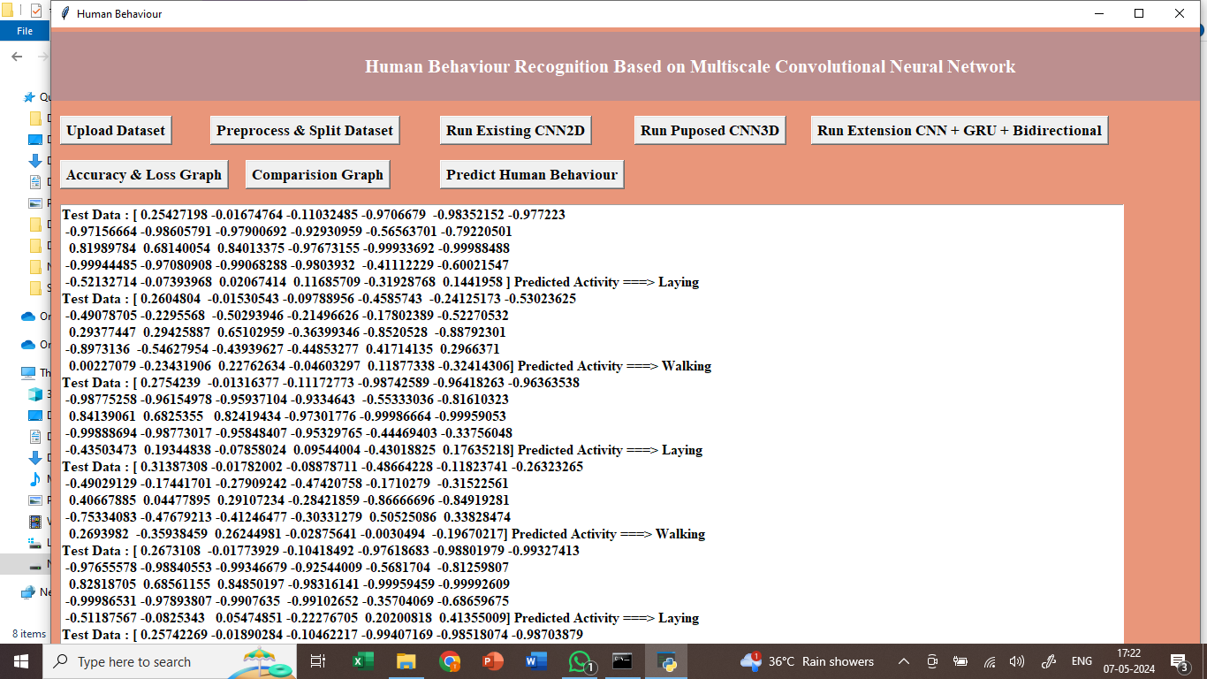
In above screen loaded test data and then predicting using extension model and in output in square bracket we can see Test Data Values and after arrow symbol can see predicted activity as Standing or any other activity.
Note: sometime propose model accuracy may be less so rerun all modules to avoid that error.

8. CONCLUSION:
In this paper, a human behavior recognition method based on improved attention mechanism is proposed. By analyzing the shortcomings of the existing channel attention mechanism, an improved attention module is proposed. In order to verify the effectiveness of the improved attention module, experiments are carried out from the aspects of visualization results, network accuracy improvement, additional network parameters and so on. The multi-scale convolution kernel is used to obtain the behavior characteristics under different receptive fields, and the convolution layer, pool layer and full connection layer are reasonably designed to further refine the characteristics, which verifies that the cross structure learning is feasible. The necessity of multi-stage progressive supervision strategy is verified by comparing the supervision in different stages; The influence of model structure on the effect of soft migration is discussed. It is found that the network is easier to converge when the structure of monitoring network is similar to that of learning network. In future work, more sensors can be used to improve the data dimension, so as to further improve the recognition accuracy. There are many parameters in the model module of our method, and the future work will focus on how to improve the lightweight of the model.
9. REFERENCES:
1. X.-J. Gu, P. Shen, H.-W. Liu, J. Guo and Z.-F. Wei, "Human behavior recognition based on bone spatio-temporal map", Comput. Eng. Des., vol. 43, no. 4, pp. 1166-1172, 2022.
Show in Context Google Scholar
2. M. Z. Sun, P. Zhang and B. Su, "Overview of human behavior recognition methods based on bone data features", Softw. Guide, vol. 21, no. 4, pp. 233-239, 2022.
Show in Context Google Scholar
3. Z. He, "Design and implementation of rehabilitation evaluation system for the disabled based on behavior recognition", J. Changsha Civil Affairs Vocational Tech. College, vol. 29, no. 1, pp. 134-136, 2022.
Show in Context Google Scholar
4. C. Y. Zhang, H. Zhang, W. He, F. Zhao, W. Q. Li, T. Y. Xu, et al., "Video based pedestrian detection and behavior recognition", China Sci. Technol. Inf., vol. 11, no. 6, pp. 132-135, 2022.
Show in Context Google Scholar
5. X. Ding, Y. Zhu, H. Zhu and G. Liu, "Behavior recognition based on spatiotemporal heterogeneous two stream convolution network", Comput. Appl. Softw., vol. 39, no. 3, pp. 154-158, 2022.
Show in Context Google Scholar
6. S. Huang, "Progress and application prospect of video behavior recognition", High Tech Ind., vol. 27, no. 12, pp. 38-41, 2021.
Show in Context Google Scholar
7. Y. Lu, L. Fan, L. Guo, L. Qiu and Y. Lu, "Identification method and experiment of unsafe behaviors of subway passengers based on Kinect", China Work Saf. Sci. Technol., vol. 17, no. 12, pp. 162-168, 2021.
Show in Context Google Scholar
8. X. Ma and J. Li, "Interactive behavior recognition based on low rank sparse optimization", J. Inner Mongolia Univ. Sci. Technol., vol. 40, no. 4, pp. 375-381, 2021.
Show in Context Google Scholar
9. Z. Zhai and Y. Zhao, "DS convLSTM: A lightweight video behavior recognition model for edge environment", J. Commun. Univ. China Natural Science Ed., vol. 28, no. 6, pp. 17-22, 2021.
Show in Context Google Scholar
10. C. Ying and S. Gong, "Human behavior recognition network based on improved channel attention mechanism", J. Electron. Inf., vol. 43, no. 12, pp. 3538-3545, 2021.
Show in Context Google Scholar
11. Z. Duan, Q. Ding, J. Wang and W. Li, "Subway station lighting control method based on passenger behavior recognition", J. Railway Sci. Eng., vol. 18, no. 12, pp. 3138-3145, 2021.
Show in Context Google Scholar
12. D. Liu, J. Yang and Q. Tang, "Research on identification technology of violations in key underground places based on video analysis", Proc. Excellent Papers Annu. Meeting Chongqing Mining Soc., pp. 71-75, 2021.
Show in Context Google Scholar
13. Y. Ye, "Key technology of human behavior recognition in intelligent device forensics based on deep learning", Apr. 2021.
Show in Context Google Scholar
14. Y. Li, "Mining the spatiotemporal distribution law of CNG gas dispensing sub station and identifying abnormal behaviors based on machine learning", Apr. 2021.
Show in Context Google Scholar
15. W. Wang, "Research on behavior recognition based on video image and virtual reality interaction application", Mar. 2021.
Show in Context Google Scholar
16. J. Wang, "Design and implementation of enterprise e-mail security analysis platform based on user behavior identification", J. Shanghai Inst. Shipping Transp. Sci., vol. 43, no. 4, pp. 59-64, 2020.
Google Scholar
17. K. Han and Z. Huang, "A fall behavior recognition method based on the dynamic characteristics of human posture", J. Hunan Univ. Natural Sci. Ed., vol. 47, no. 12, pp. 69-76, 2020.
Show in Context Google Scholar
18. F. Wang, "Research on attitude estimation and behavior recognition based on deep learning in logistics warehousing", 2020.
Show in Context Google Scholar
19. Y. Ying, "Analysis of prenatal behavior characteristics of Hu sheep and development of monitoring system based on embedded system", 2020.
Show in Context Google Scholar
20. J. Bao and H. Jin, "A semi supervised learning method for identifying intrusion behaviors in ship LAN", Ship Sci. Technol., vol. 42, no. 24, pp. 136-138, 2020.
Show in Context Google Scholar
21. L. Zhang, Y. Zhang, M. Li, X. Shi, B. Zhai and W. Wang, "Identification method of downhole personnel behavior based on CSI", J. Internet Things, vol. 4, no. 4, pp. 26-31, 2020.
Show in Context Google Scholar
22. Y. Zhang and K. Jia, "Case study on identification and prevention of financial fraud", Bus. Accounting, vol. 17, no. 24, pp. 101-104, 2020.
Show in Context Google Scholar
23. Y. Li and L. Xie, "A behavior recognition algorithm combining RGB-D video and convolutional neural network", Comput. Digit. Eng., vol. 48, no. 12, pp. 3052-3058, 2020.
Show in Context Google Scholar
24. H. Fang and Q. Lu, "Research on student classroom activity detection method based on behavior recognition", Inf. Syst. Eng., vol. 25, no. 12, pp. 27-29, 2020.
Show in Context Google Scholar
25. X. Cao, "Design and implementation of traffic violation recognition algorithm based on vehicle video", 2019.
Show in Context Google Scholar
26. Z. Xu, "Research on human behavior recognition technology based on depth feature fusion and its application in video surveillance", 2019.
Show in Context Google Scholar
27. Y. Yang, "Research on key algorithms and platform development and application of human motion behavior recognition in unrestricted scenes Xinhua college", Mar. 2020.
Show in Context Google Scholar
28. X. Huang, "Human behavior recognition method based on point projection features of bone joints", Mod. Comput., vol. 12, no. 36, pp. 3-7, 2019.
Show in Context Google Scholar
29. J. Chen, X. Xie, J. Li and G. Shi, "Behavior recognition method based on spatiotemporal attention mechanism", China Stereol. Image Anal., vol. 24, no. 4, pp. 325-333, 2019.
Show in Context Google Scholar
30. X. Han and T. Wu, "Human behavior recognition algorithm based on deep learning", Pract. Understand. Math., vol. 49, no. 24, pp. 133-139, 2019.
Show in Context Google Scholar

